**Lesson Guide** **Sheath Dress/Scoop Neck** **Draping: Beginner**

**Module 1 – Prepare the Dress Form**

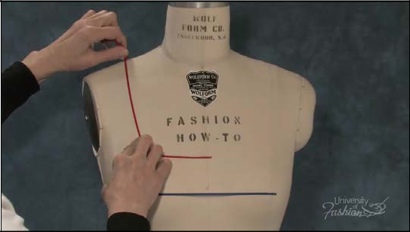

**Step 1** The first step when draping the sheath dress is to apply style tape to your dress form to establish your guidelines and neckline style line. For bust level, tape from the left apex to the side seam. Make sure that the style tape is parallel to the floor.

1

**Module 1 – Prepare the Dress Form**

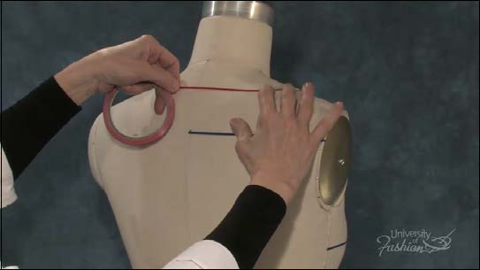

**Step 2** Tape the desired neckline both front and back.

2

**Module 1 – Prepare the Dress Form**

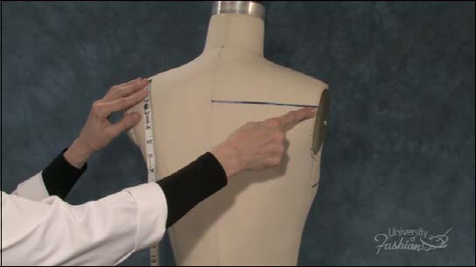

**Step 3** Tape the shoulder blade level, which is 1 /4 th the distance from your neckline to the middle of the waist tape. Tape from the center back to the armhole ridge. Be sure that this line is parallel to the floor.

3

**Module 1 – Prepare the Dress Form**

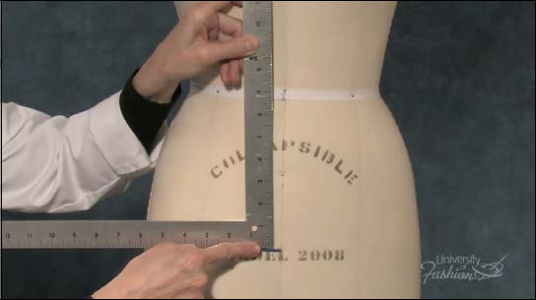

**Step 4A** Place style tape 7” down from the center of the waist tape.

4

**Module 1 – Prepare the Dress Form**

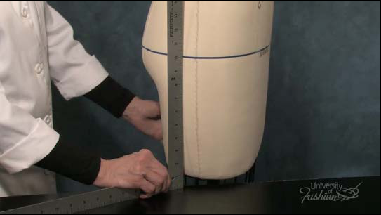

**Step 4B** Use you straight ruler against the table to check that your hip is parallel to the floor.

5

**Lesson Guide** **Sheath Dress/Scoop Neck** **Draping: Beginner**

**Module 2 – Extract Measurements**

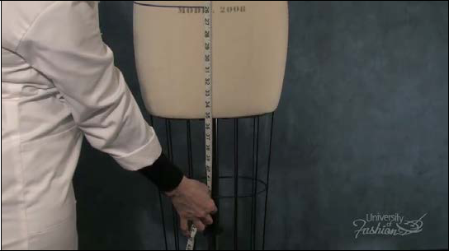

**Step 1** To prepare your front muslin block measure from the neckband to the desired dress length and add 3”. Record this measurement. This is your front block’s length.

6

**Module 2 – Extract Measurements**

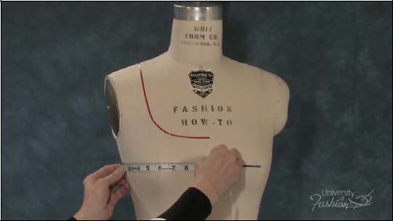

**Step 2A** Next measure across at the fullest part of the front. Measure at bust level, from side seam to center front.

7

**Module 2 – Extract Measurements**

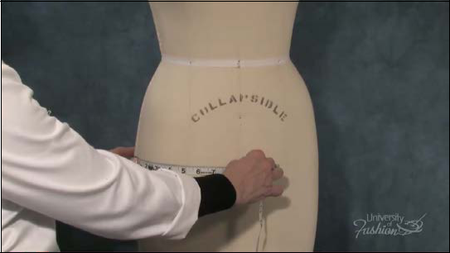

**Step 2B** Compare that measurement to the hip level from center front to side seam. Choose the larger of the 2 measurements and add 4”. Record this measurement.

8

**Module 2 – Extract Measurements**

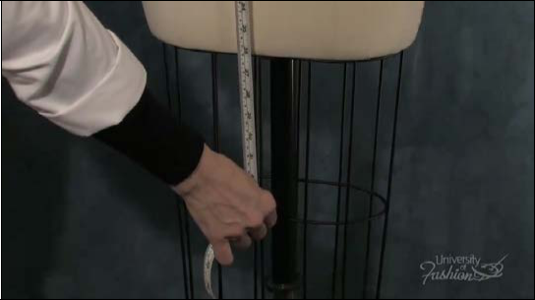

**Step 3** For the back, measure from the top of the neckband to the desired length and add 2”.

This will be the length for your back block.

9

**Module 2 – Extract Measurements**

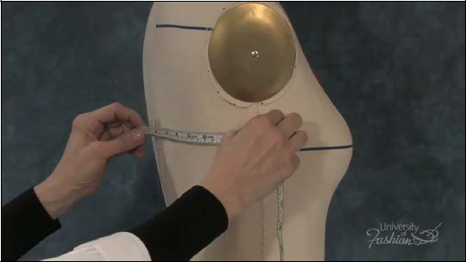

**Step 4A** Find the widest part of the back by measuring both under the arm plate from center back to side seam.

10

**Module 2 – Extract Measurements**

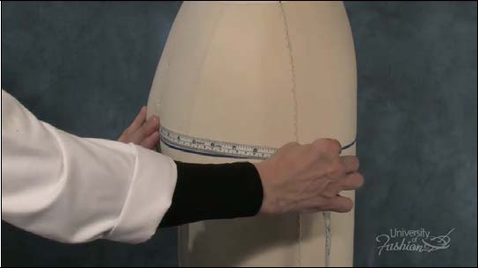

**Step 4B** Measure at the hip from center back to side seam. Take the larger of the 2 mea-surements and add 4”. Record this measurement.

11

**Lesson Guide** **Sheath Dress/Scoop Neck** **Draping: Beginner**

**Module 3 – Prepare Muslin Blocks**

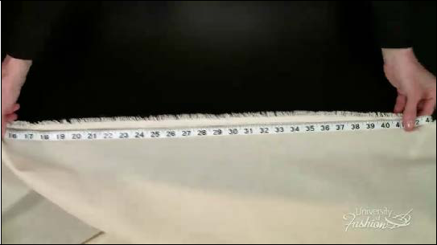

**Step 1A** Prepare you front and back muslin blocks using the measurements that you extract-ed and recorded from your dress form. Measure, then tear the muslin for the length of the block, remembering to remove the selvage edge first.

12

**Module 3 – Prepare Muslin Blocks**

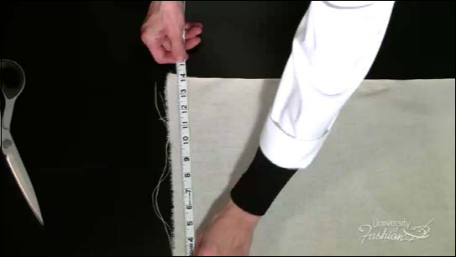

**Step 1B** Use your width measurements to tear the muslin for the width of the blocks.

13

**Module 3 – Prepare Muslin Blocks**

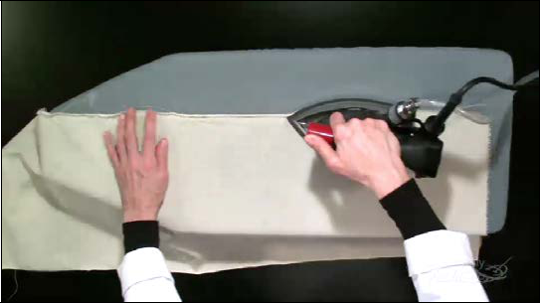

**Step 2** Press your front and back muslin blocks, first without steam, to flatten the edges.

Always press in the direction of the grain. Turn the blocks over and press the other edge.

14

**Module 3 – Prepare Muslin Blocks**

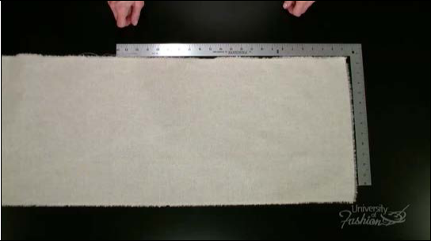

**Step 3A** Use your L square, block your front & back muslin pieces, so that the corners and your grains are at right angles to each other. Pull the corners to get the pieces to block per-fectly.

15

**Module 3 – Prepare Muslin Blocks**

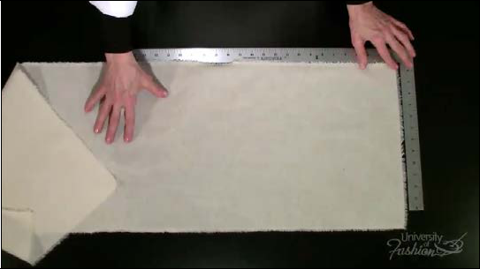

**Step 3B** Flip the blocks over and check that the other edge is a right angle. It is very import-ant that your grainlines are straight when draping.

16

**Module 3 – Prepare Muslin Blocks**

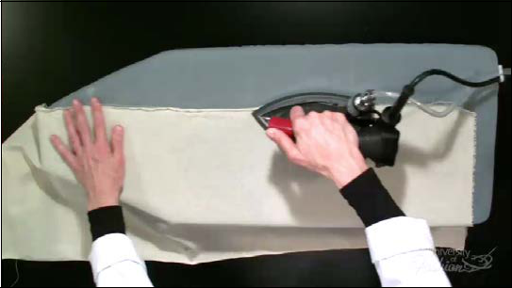

**Step 4** Once your pieces are perfectly blocked give a final pressing, this time using steam.

17

**Lesson Guide** **Sheath Dress/Scoop Neck** **Draping: Beginner**

**Module 4 – Measurements & Mark Guidelines**

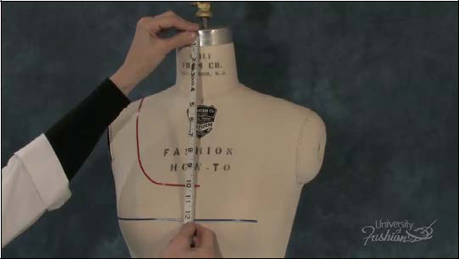

**Step 1A** You will need to record the following measurements when marking your muslin blocks beginning with the front neckband to bust level.

18

**Module 4 – Measurements & Mark Guidelines**

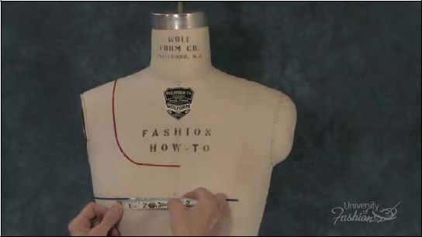

**Step 1B** Measure the apex to center front.

19

**Module 4 – Measurements & Mark Guidelines**

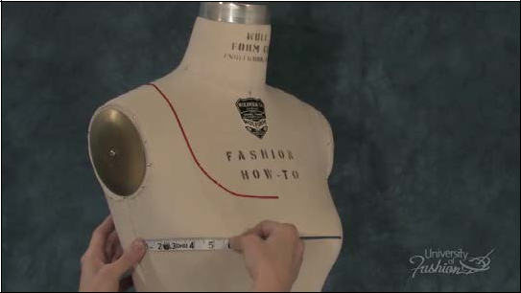

**Step 1C** Measure the side seam to apex + 1 /8” ease.

20

**Module 4 – Measurements & Mark Guidelines**

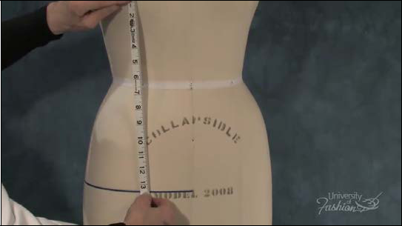

**Step 1D** Measure the apex to hipline.

21

**Module 4 – Measurements & Mark Guidelines**

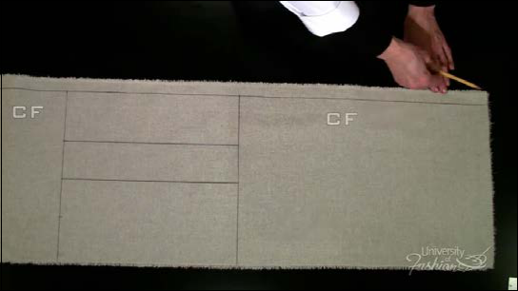

**Step 2** From the top of your front block, measure in 1” from the right side edge and drag a guideline down, this represents center front.

22

**Module 4 – Measurements & Mark Guidelines**

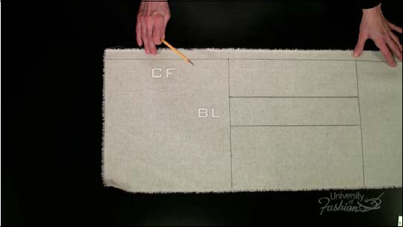

**Step 3** From the top of the muslin, measure down your neckband to apex measurement and drag a guideline across your muslin block. This represents the bust level.

23

**Module 4 – Measurements & Mark Guidelines**

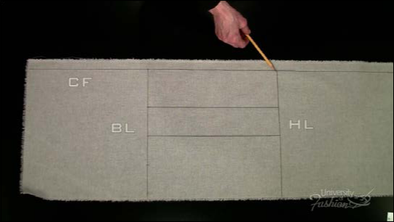

**Step 4** Take the measurement from apex to hipline and drag a grainline across. This rep-resents the hipline.

24

**Module 4 – Measurements & Mark Guidelines**

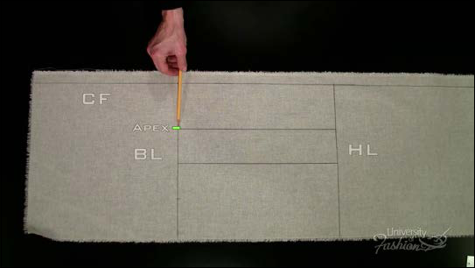

**Step 5A** From the center front line measure across the bust level to the apex and place a mark.

25

**Module 4 – Measurements & Mark Guidelines**

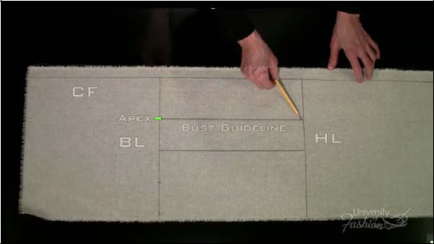

**Step 5B** At this mark, drop a bust guideline down to the hipline.

26

**Module 4 – Measurements & Mark Guidelines**

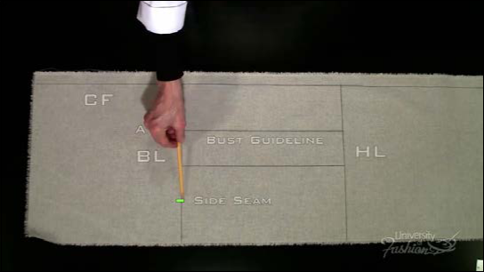

**Step 6** Taking your apex to side seam measurement, including the 1 /8”ease, place a mark on the bust level. This represents side seam.

27

**Module 4 – Measurements & Mark Guidelines**

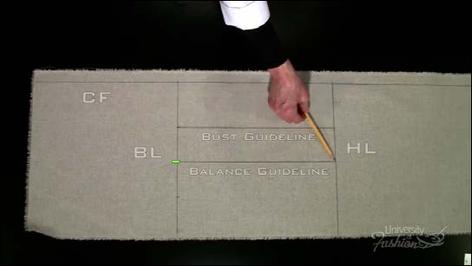

**Step 7** Divide the side seam to apex on the bust level and drag a guideline down. This is your balance guideline.

28

**Module 4 – Measurements & Mark Guidelines**

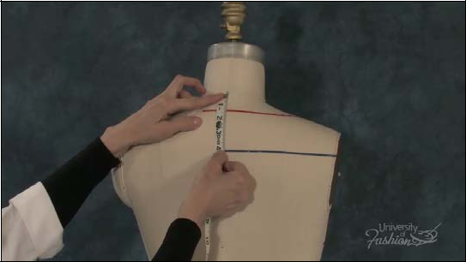

**Step 8** For your back block, measure from the neck to the shoulder blade level. Record that measurement.

29

**Module 4 – Measurements & Mark Guidelines**

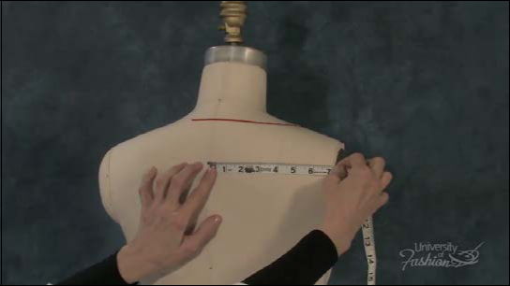

**Step 9** Measure from center back to the armhole ridge plus 1/4” ease.

30

**Module 4 – Measurements & Mark Guidelines**

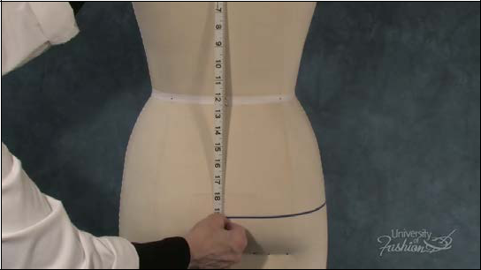

**Step 10** Measure the shoulder blade to hipline at center back. Record that measurement.

31

**Module 4 – Measurements & Mark Guidelines**

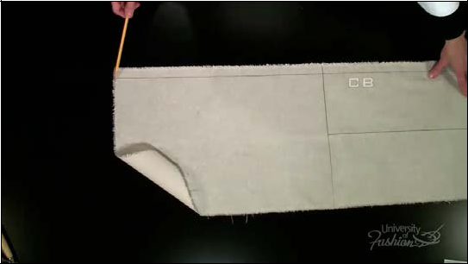

**Step 11** Start from the top and measure in 1” from the left side of the muslin block. Drag a guideline down. This is your center back.

32

**Module 4 – Measurements & Mark Guidelines**

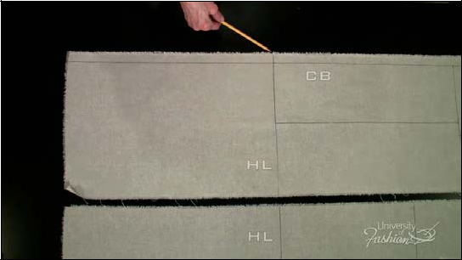

**Step 12** Lay your back muslin block alongside your front block and transfer the hip guideline the same distance from the bottom as your front. This is your back hipline.

33

**Module 4 – Measurements & Mark Guidelines**

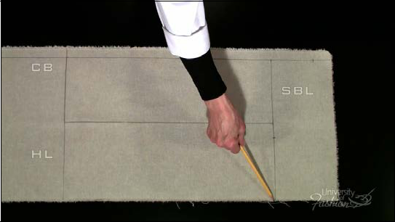

**Step 13** At the back hipline, measure up your hip to shoulder blade measurement and drag a guideline across. This is the shoulder blade level.

34

**Module 4 – Measurements & Mark Guidelines**

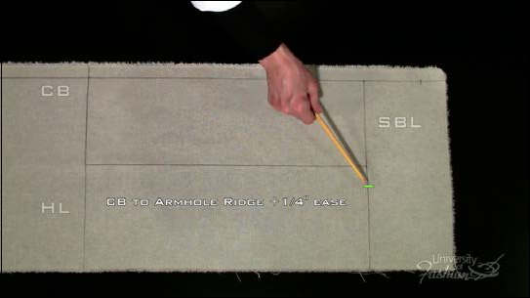

**Step 14** On the shoulder blade level measure from center back to the armhole ridge plus the 1/4” ease and place a mark.

35

**Module 4 – Measurements & Mark Guidelines**

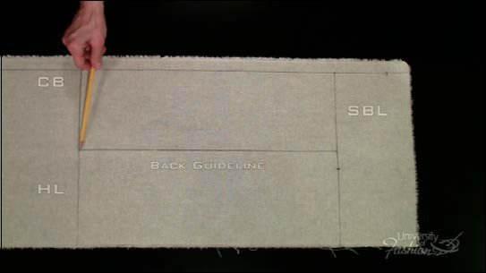

**Step 15** Measure on the shoulder blade level 1 1/4” in from the armhole and drop a guideline down to the hipline. This is a back guideline.

36

**Module 4 – Measurements & Mark Guidelines**

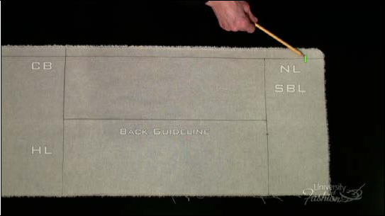

**Step 16** On center back, measure up your shoulder blade level to the neckline measurement and place a mark.

37

**Module 4 – Measurements & Mark Guidelines**

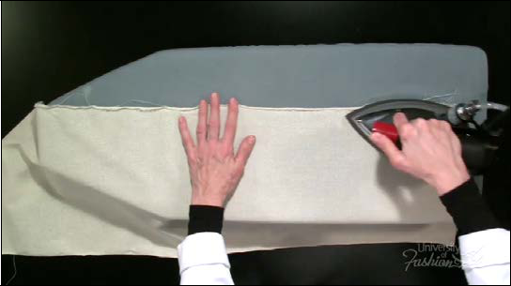

**Step 17** Once you marked your muslin blocks give a final blocking and pressing in prepara-tion for draping.

38

**Module 4 – Measurements & Mark Guidelines**

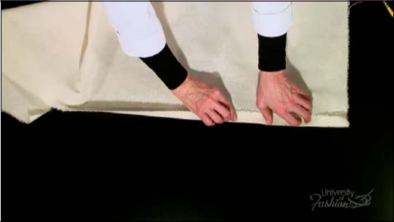

**Step 18** Bend back and fingerpress the 1” extension on your front and back muslin blocks.

Never iron this fold as it will stretch the grain.

39

**Lesson Guide** **Sheath Dress/Scoop Neck** **Draping: Beginner**

**Module 5 – Draping the Front**

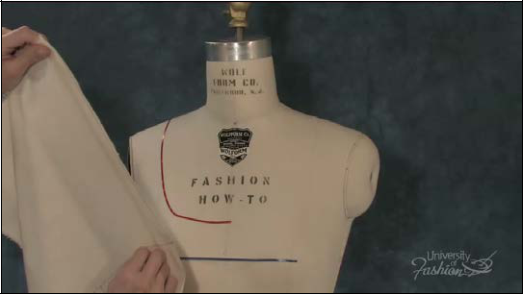

**Step 1** Begin the drape by lining up the apex marking on the muslin to the apex of the dress form and secure it with a pin.

40

**Module 5 – Draping the Front**

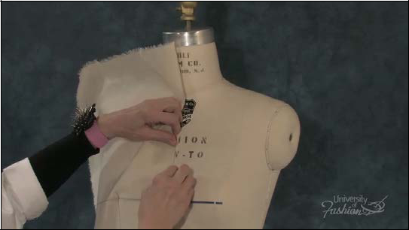

**Step 2** Pin along the center front to the neckline, keeping the muslin bust level, level to the bust level of the dress form.

41

**Module 5 – Draping the Front**

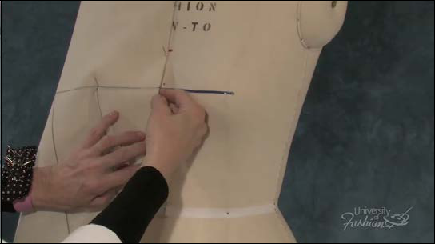

**Step 3A** As you pin the center front from bust level to hipline make sure that you allow for bust ease. Meaning that you do not pin the muslin flat to the form in the area between the left and right apex points.

42

**Module 5 – Draping the Front**

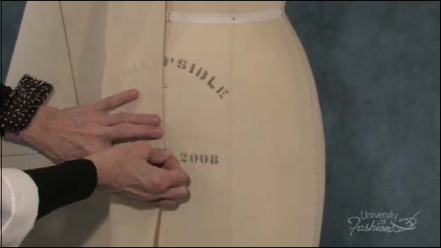

**Step 3B** Place pins at the hipline and at the end of the torso.

43

**Module 5 – Draping the Front**

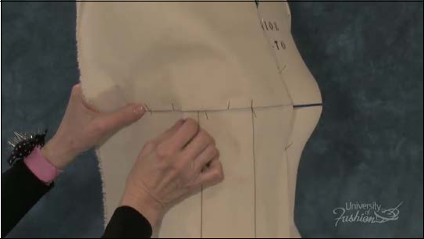

**Step 4** Pin along the bust level on the top edge of the style tape, from apex to the side seam.

Secure your pins in alternating directions, this will help stabilize the muslin while you drape.

Distribute the 1 /8” ease between the apex and side seam.

44

**Module 5 – Draping the Front**

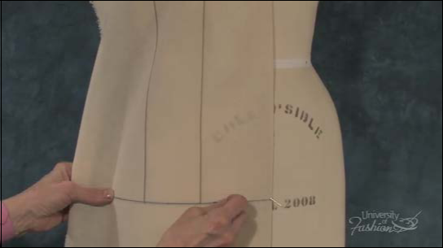

**Step 5** Smooth the muslin at the hipline to the bust guideline and place a pin on the top edge of the style tape.

45

**Module 5 – Draping the Front**

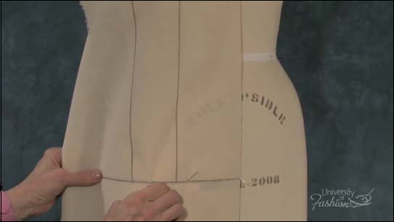

**Step 6** ATake a 1 /8” ease pinch between your bust and balance guideline.

46

**Module 5 – Draping the Front**

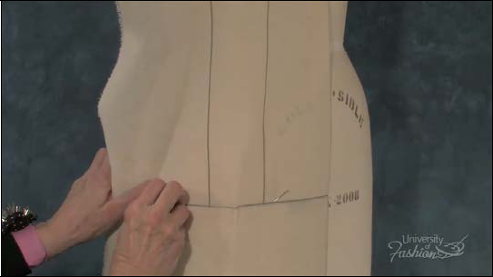

**Step 6B** Place a pin at the side seam/hipline intersection.

47

**Module 5 – Draping the Front**

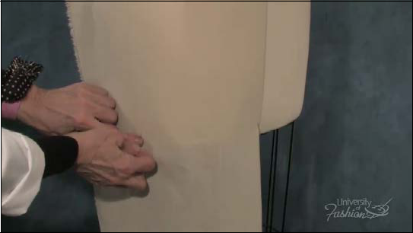

**Step 6C** Place another pin at the side seam /torso intersection, making sure that add ease at the end of the torso.

48

**Module 5 – Draping the Front**

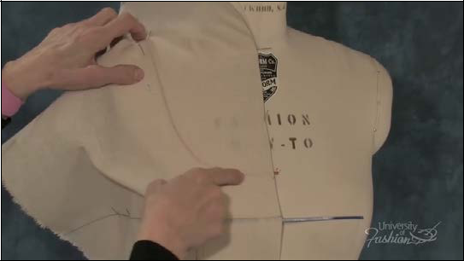

**Step 7** AMoving up to the neck area, smooth the muslin around the stylized neckline and secure a pin at the shoulder/neckline intersection.

49

**Module 5 – Draping the Front**

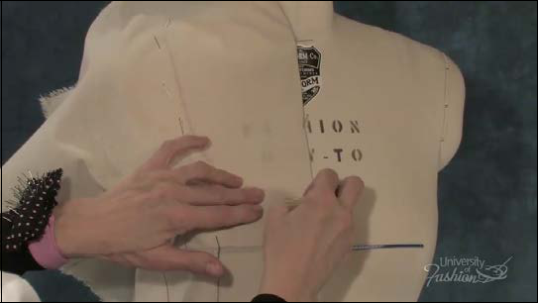

**Step 7B** Place a row of pins on center front along the stylized neckline from the shoulder to center front.

50

**Module 5 – Draping the Front**

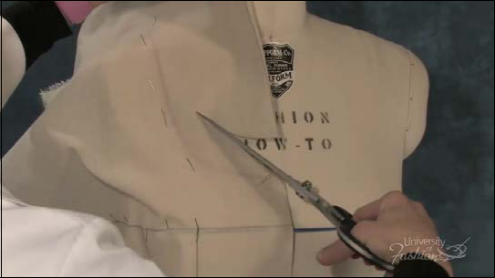

**Step 7C** Remove the holding pins above the stylized neckline at center front and trim away the excess muslin about 1” away from the stylized neckline.

51

**Module 5 – Draping the Front**

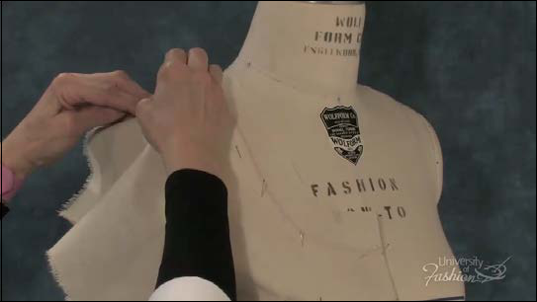

**Step 8** Smooth the muslin across the chest area and place a pin at the shoulder/armhole intersection.

52

**Module 5 – Draping the Front**

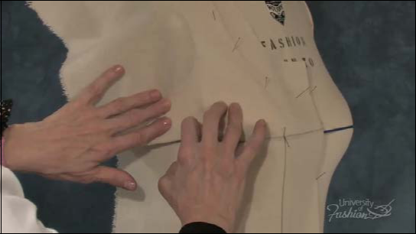

**Step 9** Smooth the muslin down and over the armhole area and place a pin at the armhole/ side seam intersection.

53

**Module 5 – Draping the Front**

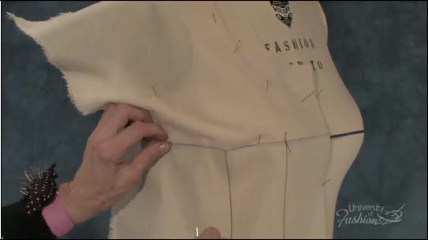

**Step 10A** Remove your bust level guideline pins up to 1” away from the apex.

54

**Module 5 – Draping the Front**

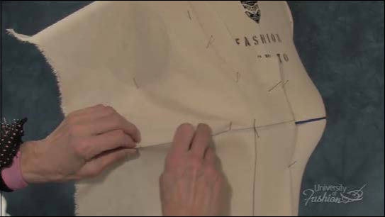

**Step 10B** Form your side seam dart with the muslin excess. The bust level guideline will be the dart’s center.

55

**Module 5 – Draping the Front**

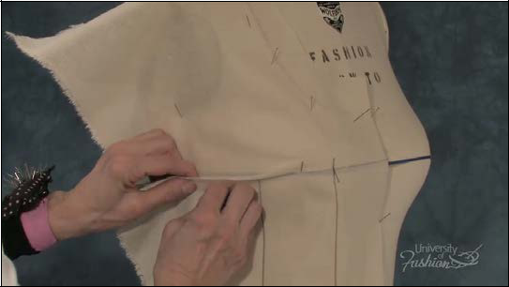

**Step 10C** Pin the dart directly in line with the side seam.

56

**Module 5 – Draping the Front**

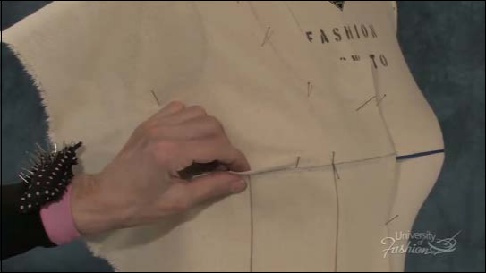

**Step 10D** Your balance guideline will help you form a nice boxy shape.

57

**Module 5 – Draping the Front**

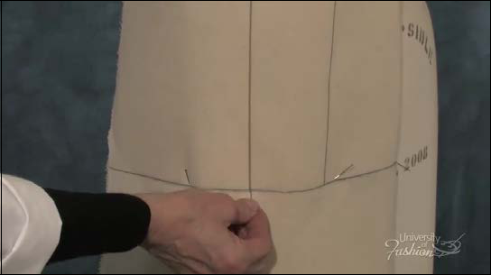

**Step 10E** Place a pin at the hip/balance guideline intersection.

58

**Module 5 – Draping the Front**

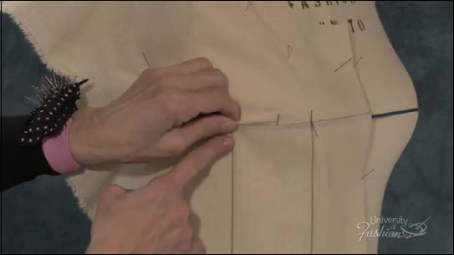

**Step 10F** Go back to the bust dart and finish by pinning the dart pick up at the balance guide-line. Make sure that you have formed a boxy shape.

59

**Lesson Guide** **Sheath Dress/Scoop Neck** **Draping: Beginner**

**Module 6 – Marking the Front**

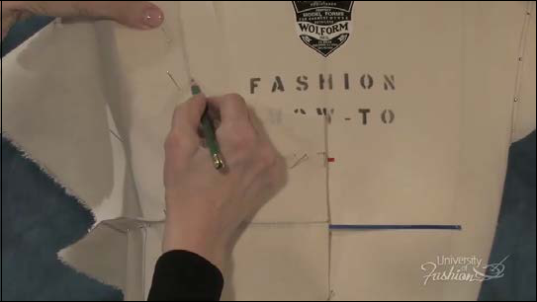

**Step 1** Begin marking the front in a counterclockwise direction. Place a dash at the center front/neckline intersection and then dot the neckline until you reach the shoulder.

60

**Module 6 – Marking the Front**

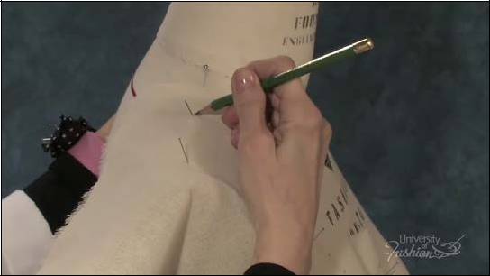

**Step 2** Crossmark the shoulder/neckline intersection.

61

**Module 6 – Marking the Front**

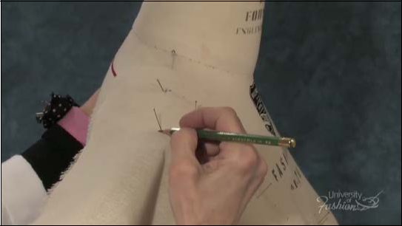

**Step 3** Crossmark the shoulder/armhole intersection.

62

**Module 6 – Marking the Front**

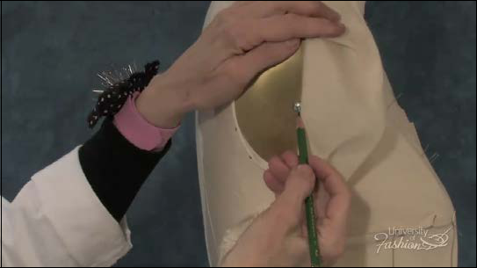

**Step 4A** Dot the armhole ridge until you reach the level of the screw on the arm plate.

63

**Module 6 – Marking the Front**

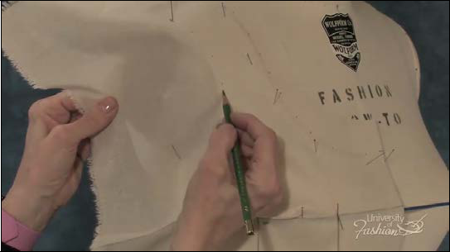

**Step 4B** Place a crossmark at the armhole/screw plate level.

64

**Module 6 – Marking the Front**

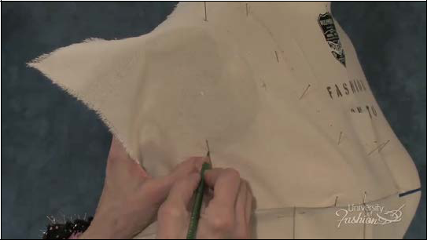

**Step 5** Crossmark the underarm/side seam intersection.

65

**Module 6 – Marking the Front**

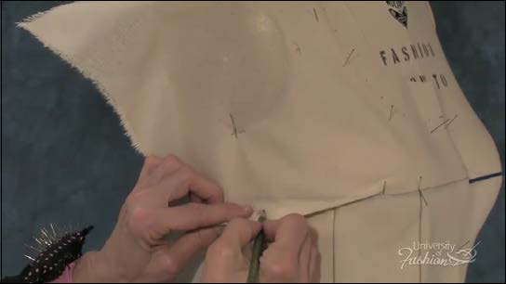

**Step 6A** Mark the bust dart on both sides at the side seam.

66

**Module 6 – Marking the Front**

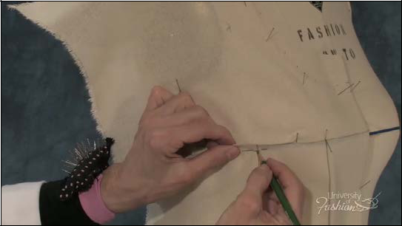

**Step 6B** Mark both sides of the dart at the bust level guideline.

67

**Module 6 – Marking the Front**

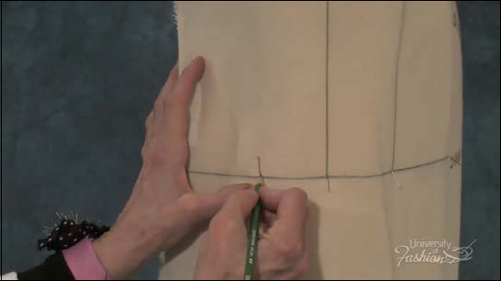

**Step 7** Place a crossmark at the side seam/hipline intersection.

68

**Module 6 – Marking the Front**

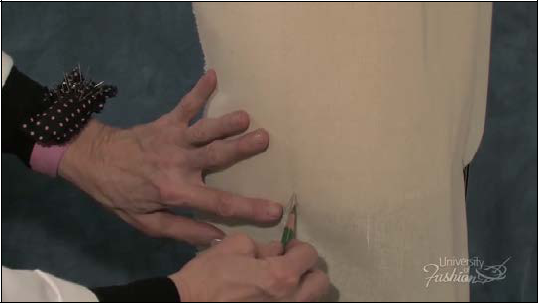

**Step 8** Crossmark the side seam/torso intersection.

69

**Module 6 – Marking the Front**

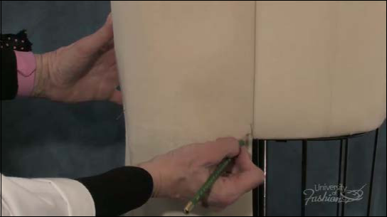

**Step 9** Crossmark the center front/torso intersection.

70

**Module 6 – Marking the Front**

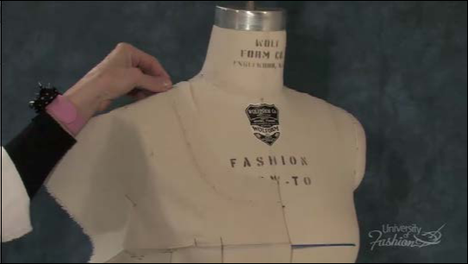

**Step 10** Be sure that you have captured all of your markings before removing the front drape from the dress form.

71

**Lesson Guide** **Sheath Dress/Scoop Neck** **Draping: Beginner**

**Module 7 – Trueing the Front – Part 1**

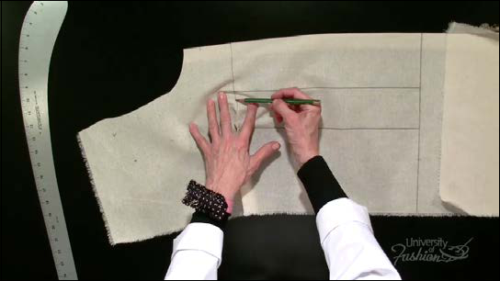

**Step 1** Begin trueing by placing your drape face-up on the table. Place a mark 1” away from the apex indicating the bust dart’s vanishing point.

72

**Module 7 – Trueing the Front – Part 1**

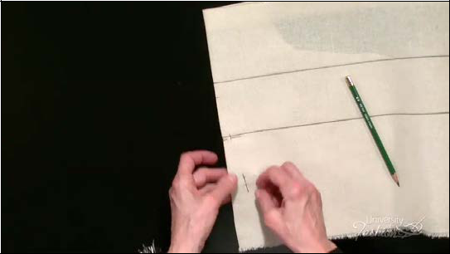

**Step 2A** Fold the muslin over on the bust guideline and redirect the bust dart pins so that they are at a right angle to the fold.

73

**Module 7 – Trueing the Front – Part 1**

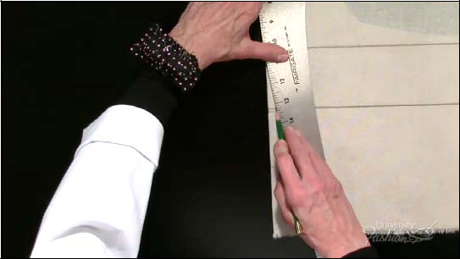

**Step 2B** Use your hip curve to connect your dart marks, from vanishing point to the side seam marks.

74

**Module 7 – Trueing the Front – Part 1**

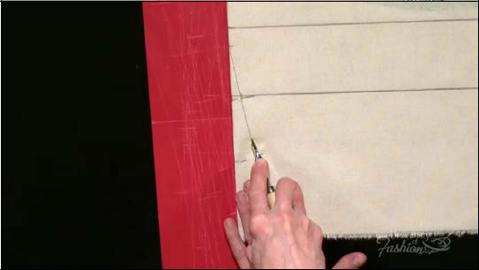

**Step 2C** Slip your tracing paper face up underneath the dart and trace the dart leg onto the other side.

75

**Module 7 – Trueing the Front – Part 1**

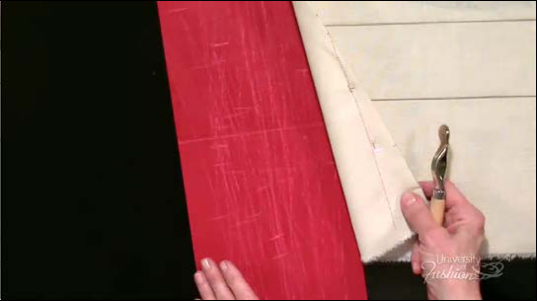

**Step 2D** Check that your tracing was successful.

76

**Module 7 – Trueing the Front – Part 1**

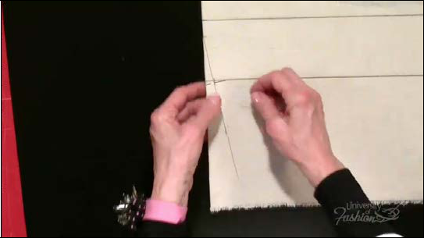

**Step 2E** Remove your dart pins.

77

**Module 7 – Trueing the Front – Part 1**

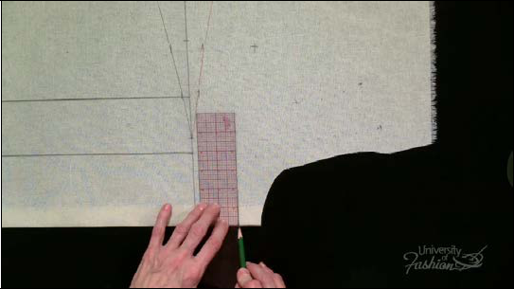

**Step 3A** At the neckline, square a line off center front for approximately 2”.

78

**Module 7 – Trueing the Front – Part 1**

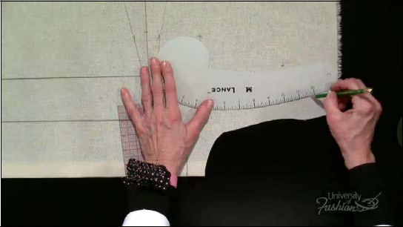

**Step 3B** Use your styling curve and your French curve to connect the neckline markings.

79

**Module 7 – Trueing the Front – Part 1**

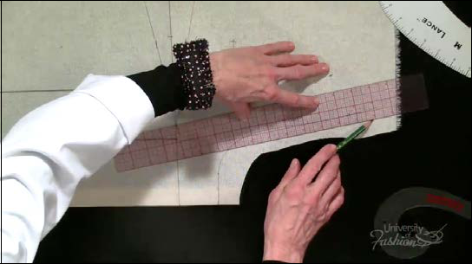

**Step 3C** Add 1/2” seam allowance to the neckline with your clear plastic ruler.

80

**Module 7 – Trueing the Front – Part 1**

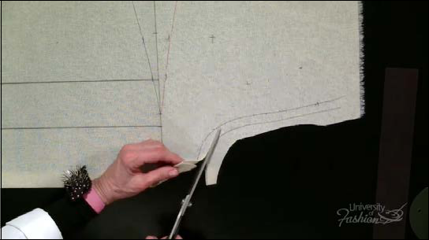

**Step 3D** Trim the excess muslin at the neckline.

81

**Module 7 – Trueing the Front – Part 1**

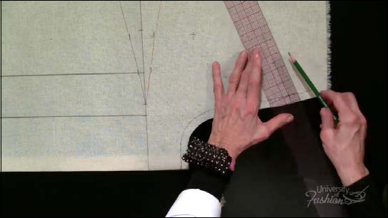

**Step 4A** True the shoulder seam, from shoulder to neckline.

82

**Module 7 – Trueing the Front – Part 1**

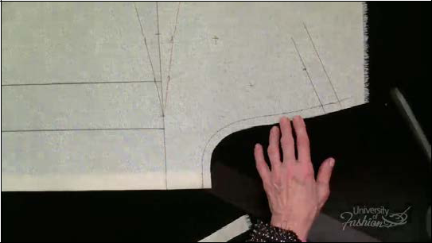

**Step 4B** Add 1” seam allowance to the shoulder seam.

83

**Module 7 – Trueing the Front – Part 1**

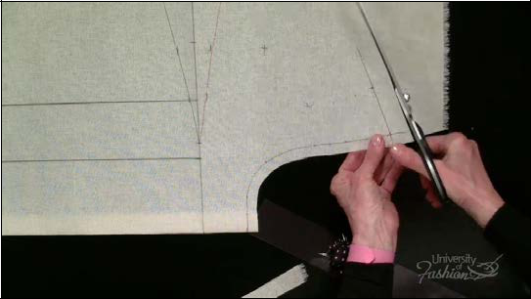

**Step 4C** Trim the excess muslin at the shoulder.

84

**Module 7 – Trueing the Front – Part 1**

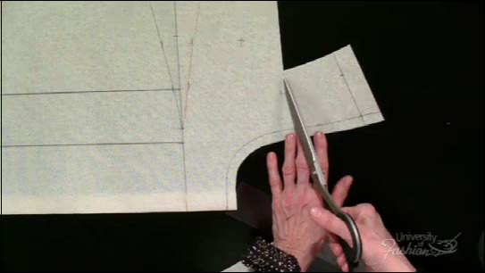

**Step 5** At the armhole, trim away a wedge of muslin within 1” of the armhole and at a angle to the screw plate level.

85

**Module 7 – Trueing the Front – Part 1**

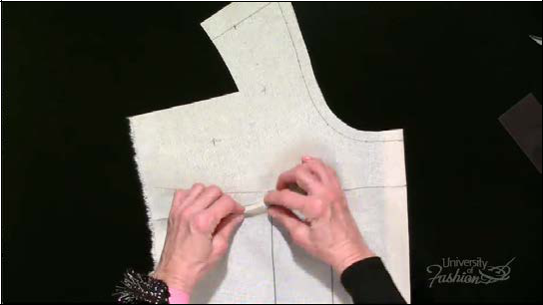

**Step 6A** To close your bust dart, fingerpress the bottom leg of the dart.

86

**Module 7 – Trueing the Front – Part 1**

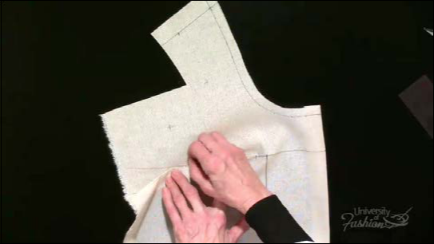

**Step 6B** Pin the bottom of the dart over the top, from side seam to vanishing point.

87

**Module 7 – Trueing the Front – Part 1**

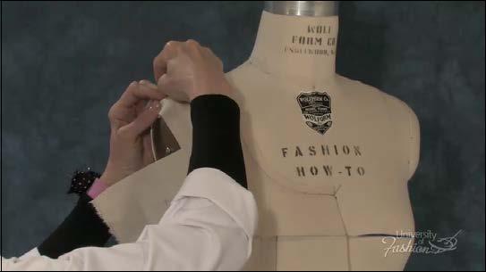

**Step 7A** Place the drape back on the dress form the way you draped it.

88

**Module 7 – Trueing the Front – Part 1**

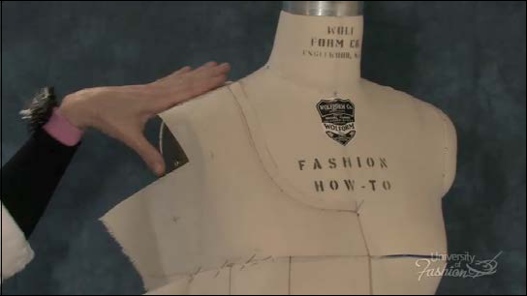

**Step 7B** Sink your pins so that they are flat on the shoulder seam allowance in preparation for draping the back.

89

**Module 7 – Trueing the Front – Part 1**

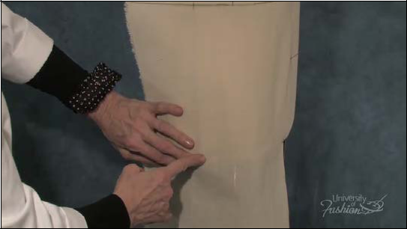

**Step 8A** Secure a row of holding pins 1”away from the side seam/armhole, the side seam/ hipline and the side seam/torso.

90

**Module 7 – Trueing the Front – Part 1**

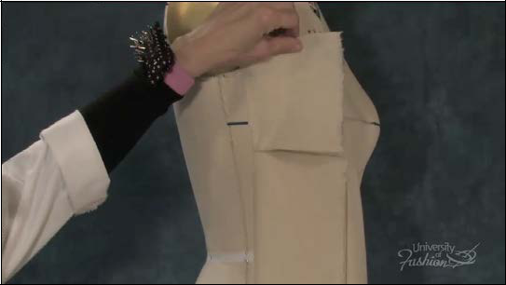

**Step 8B** Fold the side seam over onto the front and place holding pins at the top and bottom in preparation for draping the back.

91

**Lesson Guide** **Sheath Dress/Scoop Neck** **Draping: Beginner**

**Module 8 – Draping the Back**

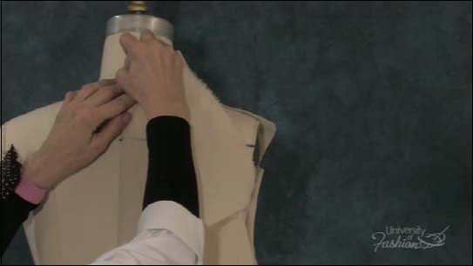

**Step 1A** Line up your back muslin block and place a pin at the center back/neckline intersec-tion.

92

**Module 8 – Draping the Back**

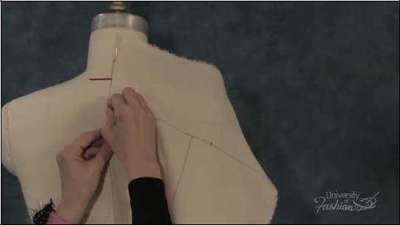

**Step 1B** Pin the shoulder blade/center back intersection on the top edge of the style tape.

93

**Module 8 – Draping the Back**

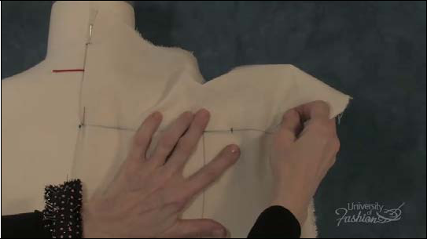

**Step 1C** Secure a pin at the shoulder blade/armhole ridge intersection.

94

**Module 8 – Draping the Back**

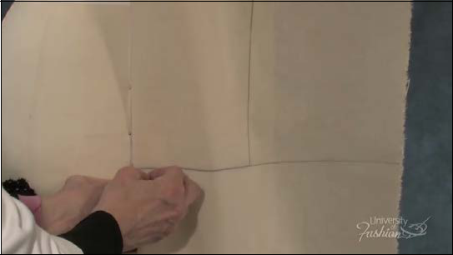

**Step 1D** Pin the center back/hipline intersection.

95

**Module 8 – Draping the Back**

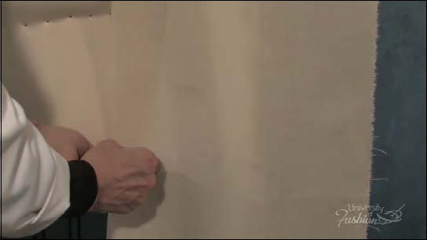

**Step 1E** Place a pin at the center back/torso intersection.

96

**Module 8 – Draping the Back**

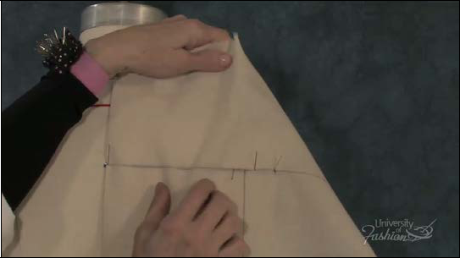

**Step 2** Working on the top of the style tape, pin along the shoulder blade level in alternating directions, trapping the ease between the guideline and center back.

97

**Module 8 – Draping the Back**

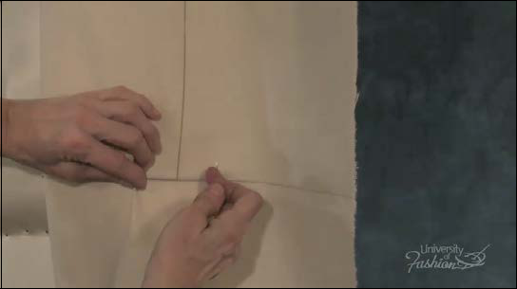

**Step 3** Place a pin at the hip/guideline intersection trapping ease between the guideline and center back.

98

**Module 8 – Draping the Back**

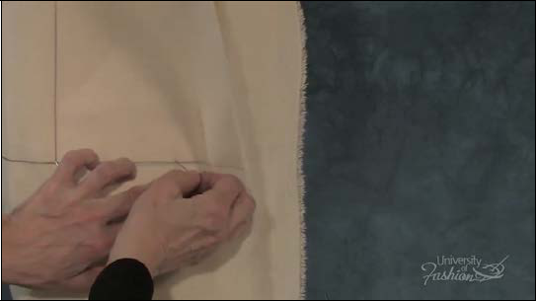

**Step 4A** Keeping your hip guideline level to the dress form, pin at the hipline/side seam inter-section.

99

**Module 8 – Draping the Back**

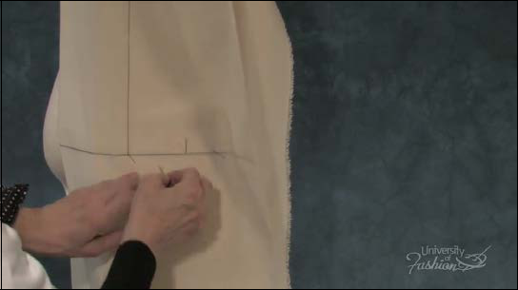

**Step 4B** Pin across the hip level in alternating directions, trapping ease between the pins.

100

**Module 8 – Draping the Back**

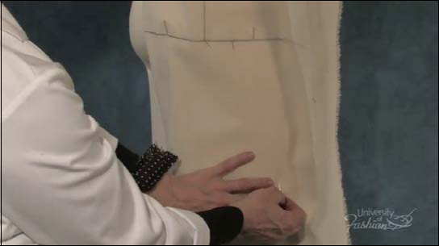

**Step 5** Pin the side seam/torso intersection making sure that you have corresponding ease between the center back and the side seam.

101

**Module 8 – Draping the Back**

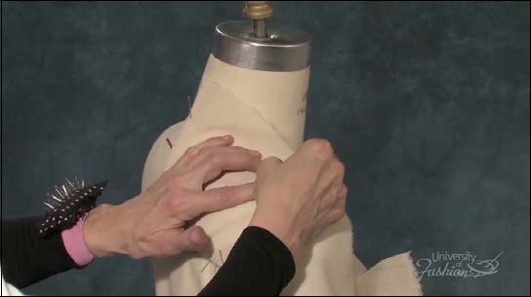

**Step 6** Moving to the neckline area, smooth the muslin over the shoulder and place a pin at the neckline/shoulder intersection.

102

**Module 8 – Draping the Back**

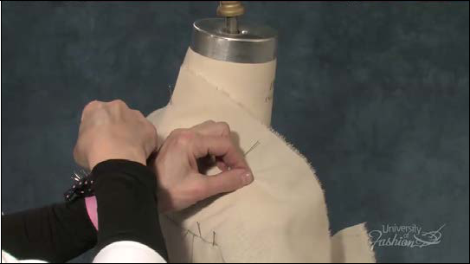

**Step 7** Pick up a pinch of ease directly over the midway point of the shoulder seam.

103

**Module 8 – Draping the Back**

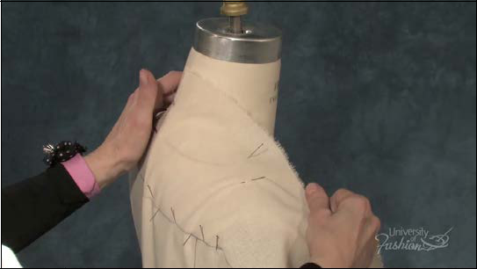

**Step 8** Gently tug on the shoulder muslin to flatten the shoulder area and pin the shoulder/ armhole intersection.

104

**Module 8 – Draping the Back**

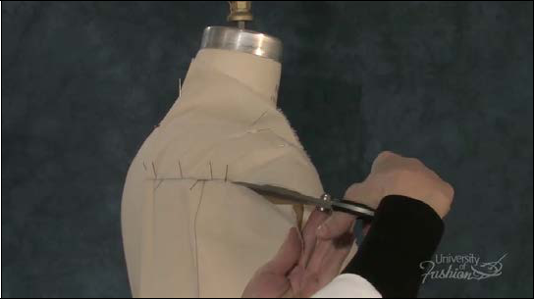

**Step 9A** In preparation for joining the front and back side seams, slash into the shoulder blade level guideline to within 1” of the back armhole ridge.

105

**Module 8 – Draping the Back**

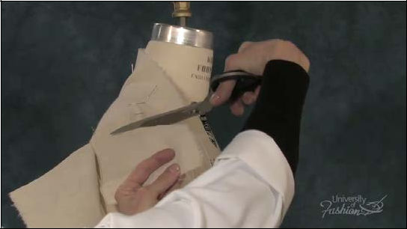

**Step 9B** Trim away excess muslin no closer than 1” from the back armhole.

106

**Module 8 – Draping the Back**

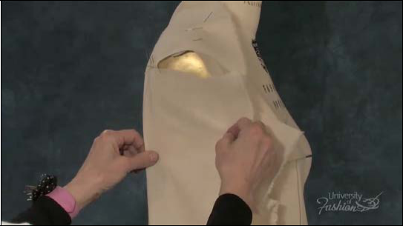

**Step 10** At the underarm, form a boxy shape then place a pin at the side seam/underarm intersection.

107

**Module 8 – Draping the Back**

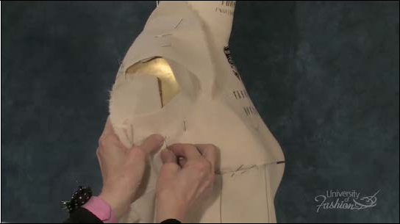

**Step 11** Release the holding pin on the front, match up the front and back side seams at the underarm intersection and pin the front and back seams together.

108

**Module 8 – Draping the Back**

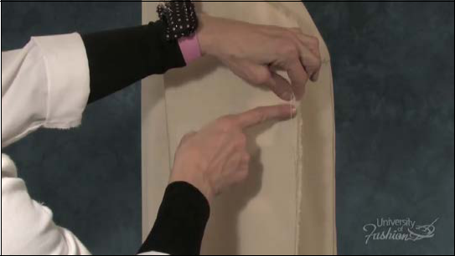

**Step 12A** The side seams must match from below the bust dart to the lower edge of the muslin. This is so that your dress is balanced. If your side seams don’t match, adjust the side seam by giving or taking more ease so that the side seams will balance. This is important especially if you are matching stripes or plaids.

109

**Module 8 – Draping the Back**

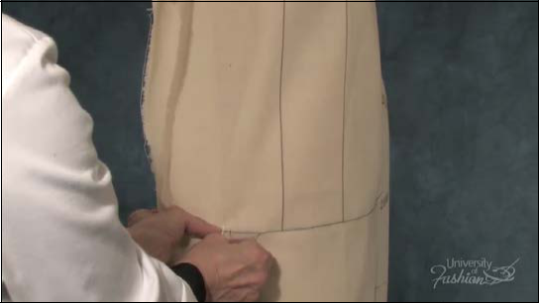

**Step 12B** Once you have balanced the side seam, pin the front and back hipline together.

110

**Module 8 – Draping the Back**

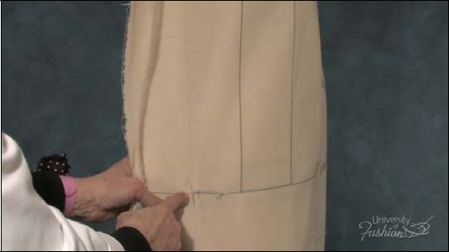

**Step 12C** Pin the front and back end of torso together.

111

**Lesson Guide** **Sheath Dress/Scoop Neck** **Draping: Beginner**

**Module 9 – Fitting the Sheath Dress**

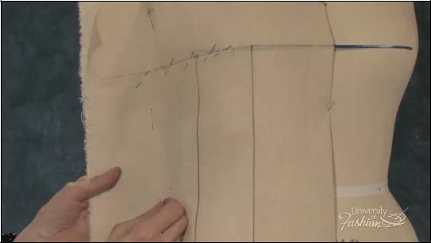

**Step 1** Pin the front and back side seams together at approximately 2” away from the side seam of the dress form from the dart down to the end of the torso.

112

**Module 9 – Fitting the Sheath Dress**

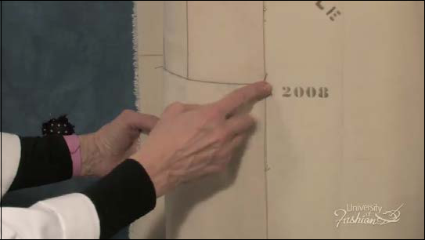

**Step 2** Remove the pins along the hipline in preparation for adding shape to the dress.

113

**Module 9 – Fitting the Sheath Dress**

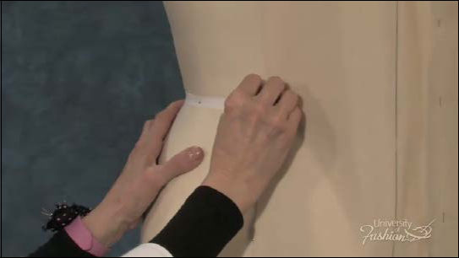

**Step 3A** Start by placing a pin so that it contours to the back waist.

114

**Module 9 – Fitting the Sheath Dress**

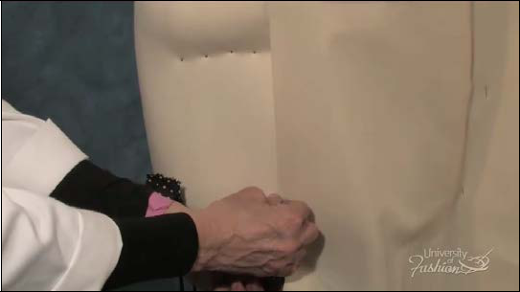

**Step 3B** Repin from the waist to the torso. You will notice that you hip guideline will shift up.

115

**Module 9 – Fitting the Sheath Dress**

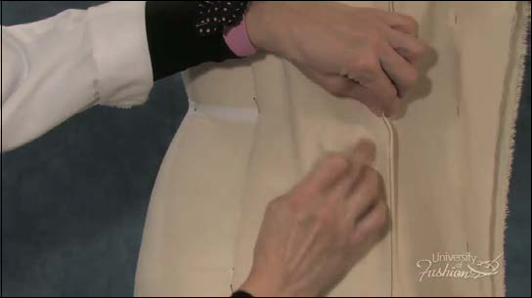

**Step 4A** Now you will form 2Back waist darts. Pick up and pin about 3/4” on the back guide-line at the waist to form the first dart.

116

**Module 9 – Fitting the Sheath Dress**

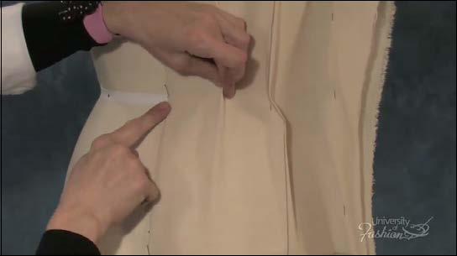

**Step 4B** The second back dart if formed midway between the balance guideline and center back and the pick up is about 3/4” pinned at the waist.

117

**Module 9 – Fitting the Sheath Dress**

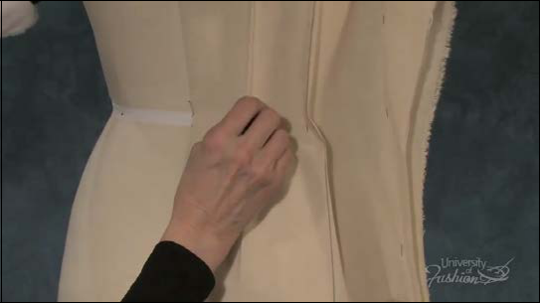

**Step 4C** Fingerpress the back darts both above and below the waistline.

118

**Module 9 – Fitting the Sheath Dress**

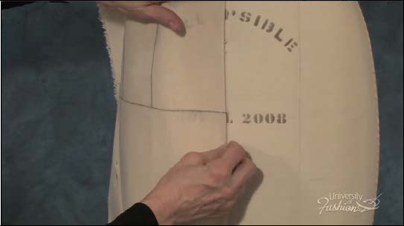

**Step 5A** SRepeat this process on the front by first repositioning your center front pin to con-tour at the waist.

119

**Module 9 – Fitting the Sheath Dress**

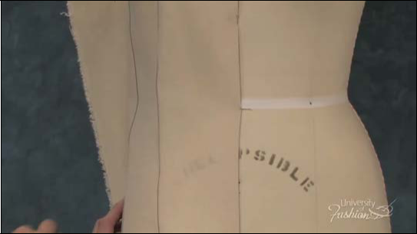

**Step 5B** Repin the hip and torso.

120

**Module 9 – Fitting the Sheath Dress**

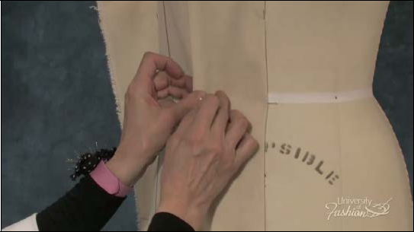

**Step 6A** The front waist has 2 darts, the first dart will be positioned at the bust guideline with a 1/2” pick up at the waist.

121

**Module 9 – Fitting the Sheath Dress**

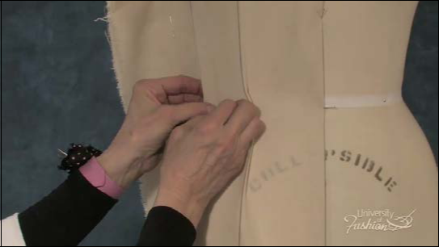

**Step 6B** The second dart is formed on the front balance guideline with 1/2” pick up at the waist. The amount of dart pick up depends upon the width of the waist and how fitted you want your dress to be.

122

**Module 9 – Fitting the Sheath Dress**

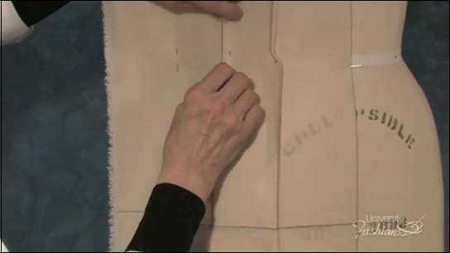

**Step 6C** Fingerpress the darts both above and below the waistline. It is important to main-tain the same amount of fit at the waist both front and back and at the side seam in order to achieve a balanced garment.

123

**Module 9 – Fitting the Sheath Dress**

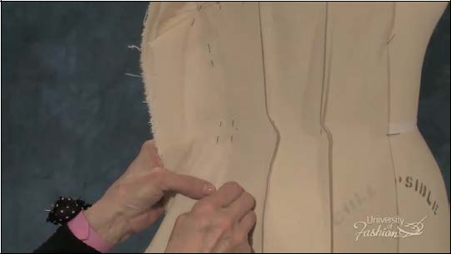

**Step 7A** Next, you will fit the side seam at the waist. Pin front and back together.

124

**Module 9 – Fitting the Sheath Dress**

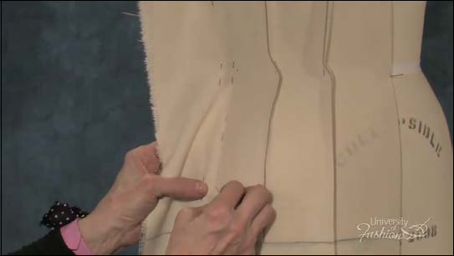

**Step 7B** Continue to pin the side seams together until you reach the hip.

125

**Module 9 – Fitting the Sheath Dress**

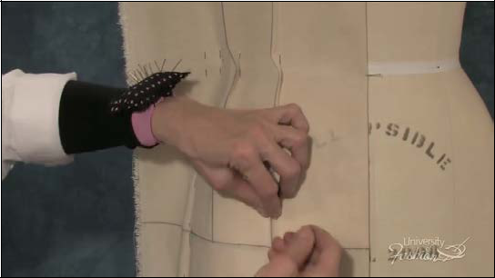

**Step 8A** Fingerpress the front darts and place a pin at the vanishing point of the front bustline dart at about 1” up from the hipline. The fuller the hip the shorter the dart.

126

**Module 9 – Fitting the Sheath Dress**

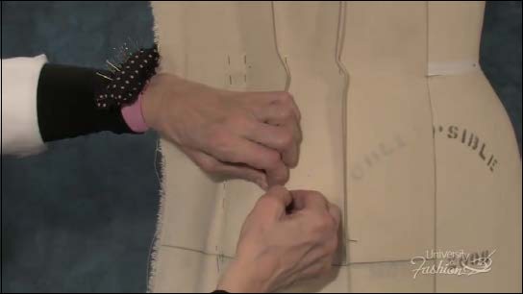

**Step 8B** The dart at the front balance guideline is shorter, due to the high hip, and ends at about 2” above the hipline.

127

**Module 9 – Fitting the Sheath Dress**

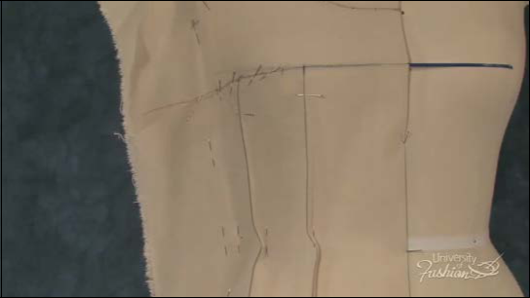

**Step 9** The vanishing points for the upper waist darts should never be closer than 1/2” away from the apex and depends upon the fullness of the bust. Place a pin at where you believe the dart wants to vanish. The fuller the bust the shorter the dart.

128

**Module 9 – Fitting the Sheath Dress**

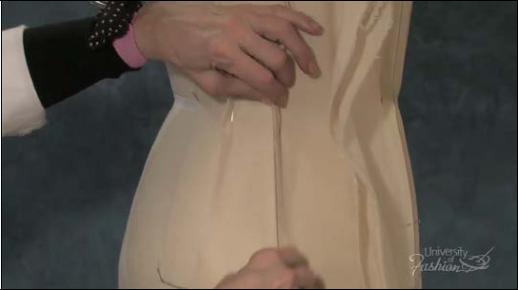

**Step 10A** Fingerpress the back balance guideline dart and place a pin at the vanishing point.

This back dart is shorter than the midway dart due to the high hip.

129

**Module 9 – Fitting the Sheath Dress**

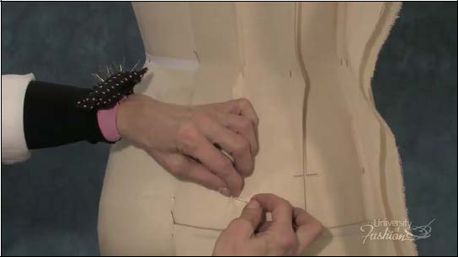

**Step 10B** Fingerpress the back midway dart and pin the vanishing point. This waist dart should never end closer than 1” away from the hipline.

130

**Lesson Guide** **Sheath Dress/Scoop Neck** **Draping: Beginner**

**Module 10 – Marking the Back and Front Side Seam**

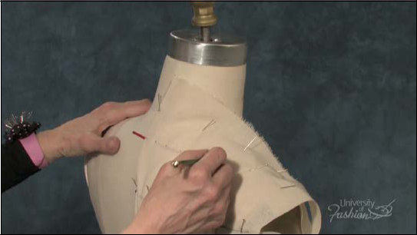

**Step 1** Begin marking the back in a clockwise manner. Place a dash at the centerback/neck-line and dot along the neck styleline.

131

**Module 10 – Marking the Back and Front Side Seam**

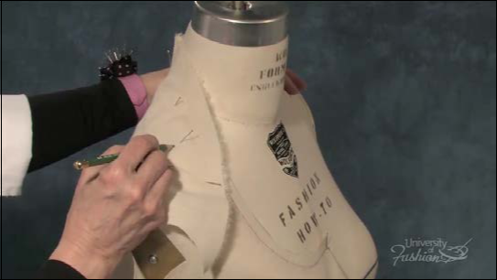

**Step 2A** Crossmark the neck/shoulder intersection.

132

**Module 10 – Marking the Back and Front Side Seam**

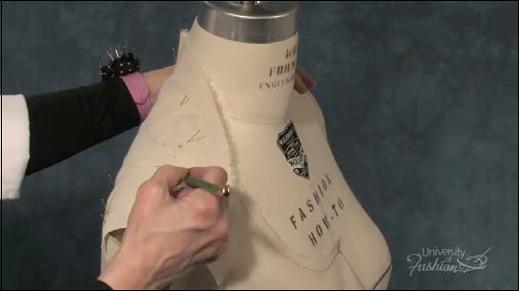

**Step 2B** Dot along the back shoulder.

133

**Module 10 – Marking the Back and Front Side Seam**

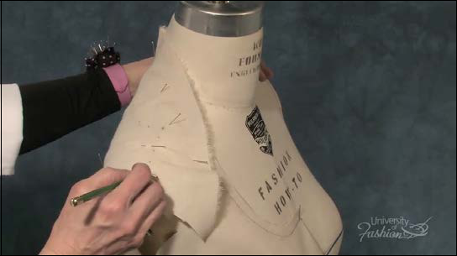

**Step 2C** Crossmark the back shoulder/armhole intersection.

134

**Module 10 – Marking the Back and Front Side Seam**

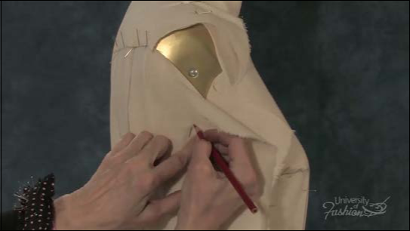

**Step 3** With your red pencil, place a crossmark at the back, side seam/armhole tight body line.

135

**Module 10 – Marking the Back and Front Side Seam**

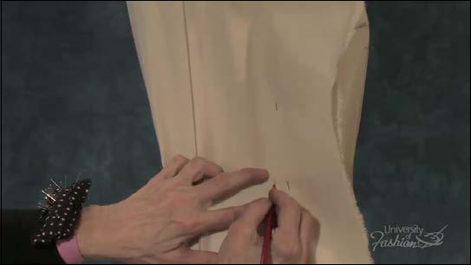

**Step 4** Crossmark the back waistline in the center of the waist tape.

136

**Module 10 – Marking the Back and Front Side Seam**

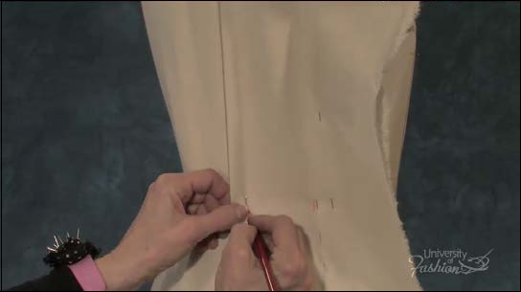

**Step 5** Crossmark both sides of the back waist darts at the center of the waist tape.

137

**Module 10 – Marking the Back and Front Side Seam**

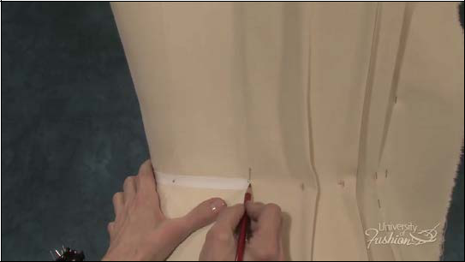

**Step 6** Place a dash at the centerback waistline intersection, again, in the center of the waist tape.

138

**Module 10 – Marking the Back and Front Side Seam**

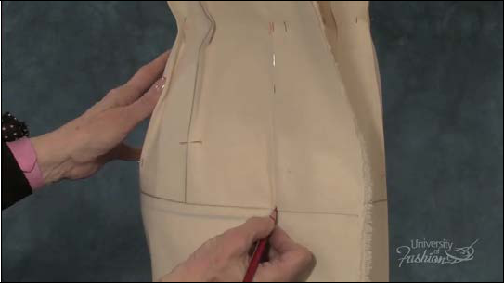

**Step 7A** Crossmark the back side seam/hipline intersection.

139

**Module 10 – Marking the Back and Front Side Seam**

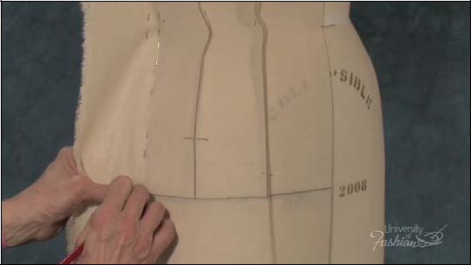

**Step 7B** Crossmark the front side seam/hipline intersection.

140

**Module 10 – Marking the Back and Front Side Seam**

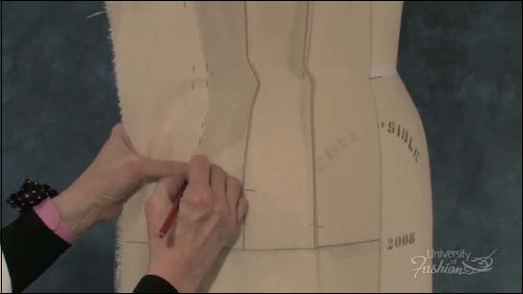

**Step 8** Mark along the side seam from hipline to waistline.

141

**Module 10 – Marking the Back and Front Side Seam**

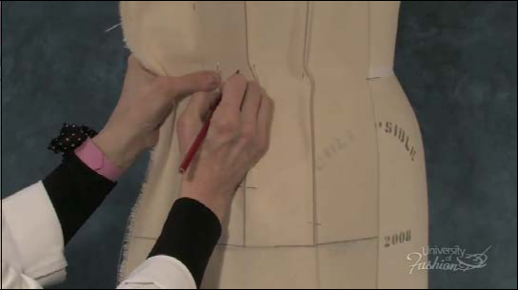

**Step 9** Crossmark the front waistline in the center of the waist tape.

142

**Module 10 – Marking the Back and Front Side Seam**

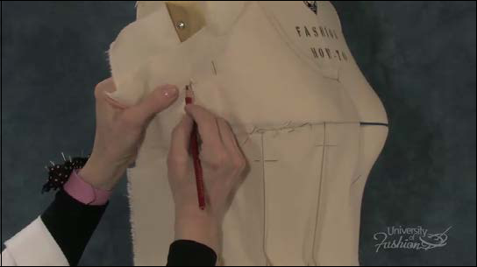

**Step 10** Crossmark the front side seam/underarm intersection.

143

**Module 10 – Marking the Back and Front Side Seam**

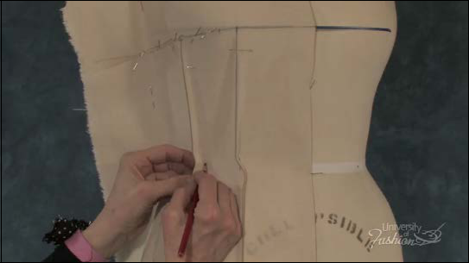

**Step 11** Crossmark both sides of the front waist darts, again, in the center of the waist tape.

144

**Module 10 – Marking the Back and Front Side Seam**

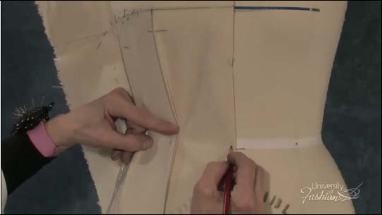

**Step 12** Place a dash mark at center front in the center of the waist tape.

145

**Module 10 – Marking the Back and Front Side Seam**

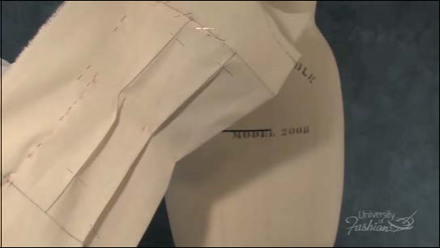

**Step 13** Make sure that you have captured all of your markings before removing the drape from the dress form. Keep the front and back sides seams pinned together.

146

**Lesson Guide** **Sheath Dress/Scoop Neck** **Draping: Beginner**

**Module 11 – Trueing the Side Seam & Front Part 2**

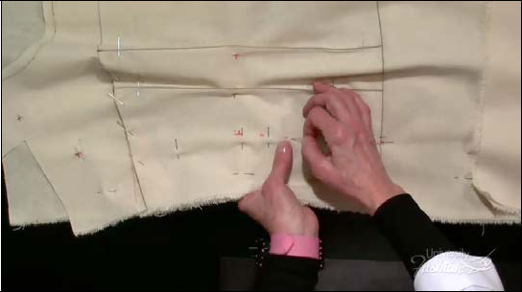

**Step 1** With the front of the drape facing up, begin by re-directing your side seam pins so that they are at right angles to the seam. Leave the pin point in place so that the muslin doesn’t slip or separate.

147

**Module 11 – Trueing the Side Seam & Front Part 2**

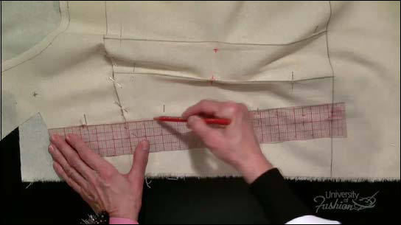

**Step 2** Use your red pencil and clear plastic ruler to connect the underarm to the waist. This is called your tight bodyline.

148

**Module 11 – Trueing the Side Seam & Front Part 2**

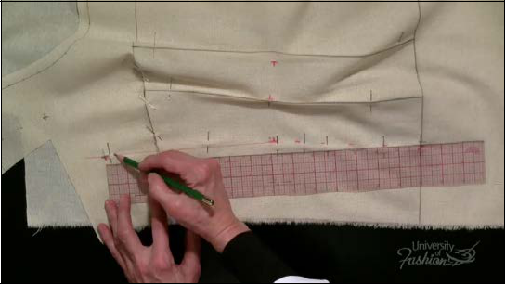

**Step 3A** With your pencil, lower your armhole 1/2” for a sleeveless dress and place a mark.

For a dress with a sleeve lower 1”.

149

**Module 11 – Trueing the Side Seam & Front Part 2**

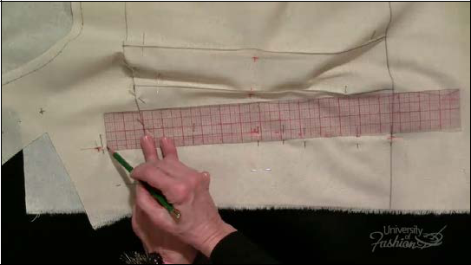

**Step 3B** Extend out 1/4” from that lowered armhole mark and place another mark. This is for bust ease. For a dress with a sleeve, you would come out 1/2”.

150

**Module 11 – Trueing the Side Seam & Front Part 2**

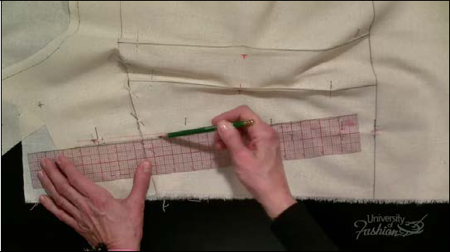

**Step 3C** Connect a line from the lowered, extended marks to the waist. This is known as your new lowered extended side seam.

151

**Module 11 – Trueing the Side Seam & Front Part 2**

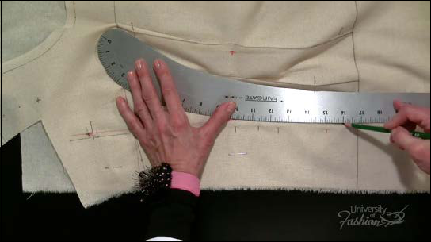

**Step 4** Use your hip curve to connect the hip at the side seam to the hipline.

152

**Module 11 – Trueing the Side Seam & Front Part 2**

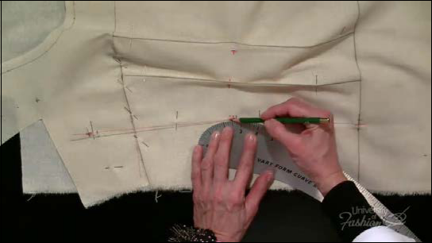

**Step 5** Reblend the waistline with your hip curve.

153

**Module 11 – Trueing the Side Seam & Front Part 2**

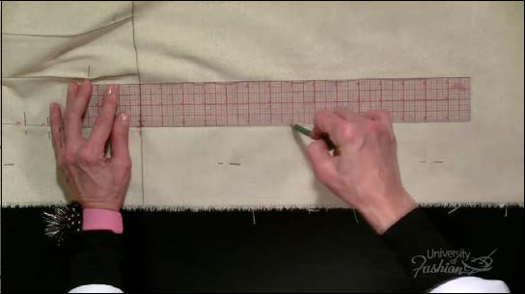

**Step 6** Use you clear plastic ruler to square a line off the hipline to form your side seam.

154

**Module 11 – Trueing the Side Seam & Front Part 2**

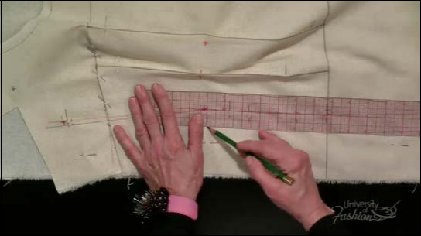

**Step 7** Add 1” seam allowance to the side seam from hem to the armhole.

155

**Module 11 – Trueing the Side Seam & Front Part 2**

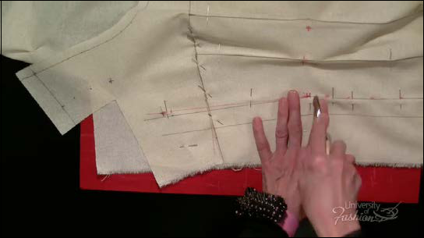

**Step 8A** Place tracing paper face-up under the side seam and trace the waist mark.

156

**Module 11 – Trueing the Side Seam & Front Part 2**

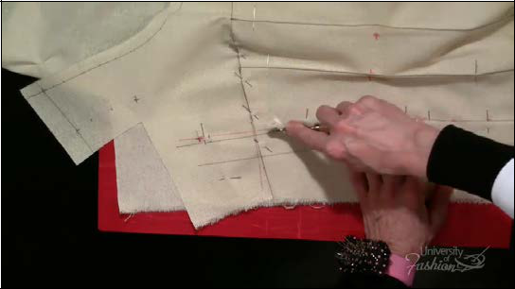

**Step 8B** Trace the tight bodyline and the lowered extended armhole mark.

157

**Module 11 – Trueing the Side Seam & Front Part 2**

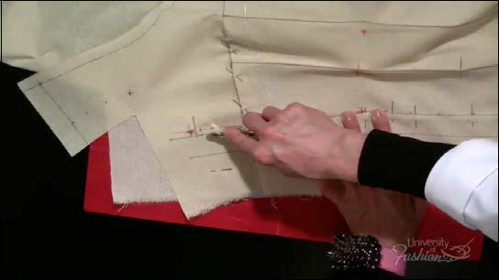

**Step 8C** Trace the lowered extended new side seam.

158

**Module 11 – Trueing the Side Seam & Front Part 2**

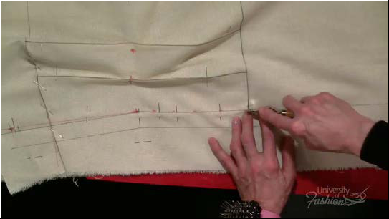

**Step 8D** Trace the side seam from hip to waist.

159

**Module 11 – Trueing the Side Seam & Front Part 2**

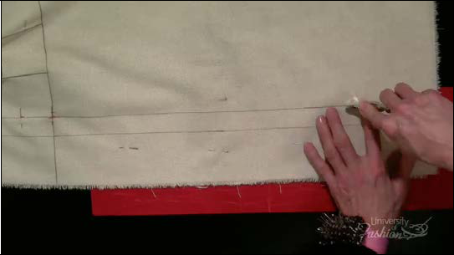

**Step 8F** Finish tracing the side seam from the hem to the hip.

160

**Module 11 – Trueing the Side Seam & Front Part 2**

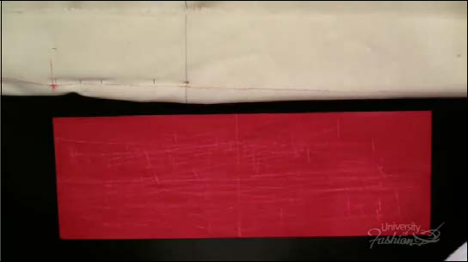

**Step 8G** Turn the muslin over to check that your tracing was successful.

161

**Module 11 – Trueing the Side Seam & Front Part 2**

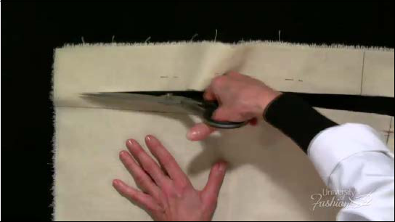

**Step 9** Trim away the excess muslin at the side seam.

162

**Module 11 – Trueing the Side Seam & Front Part 2**

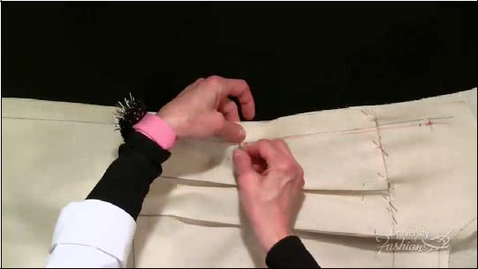

**Step 10** Remove all side seam pins and separate the front and back.

163

**Module 11 – Trueing the Side Seam & Front Part 2**

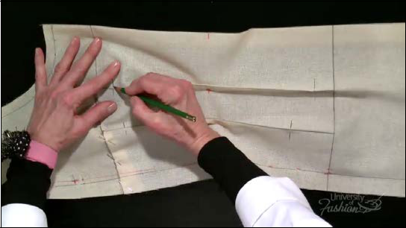

**Step 11A** Mark the vanishing points of the front darts above the waist and remove the pins.

164

**Module 11 – Trueing the Side Seam & Front Part 2**

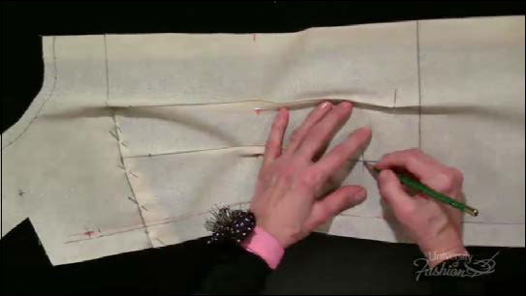

**Step 11B** Mark the vanishing points of the darts below the waist and remove those pins.

165

**Module 11 – Trueing the Side Seam & Front Part 2**

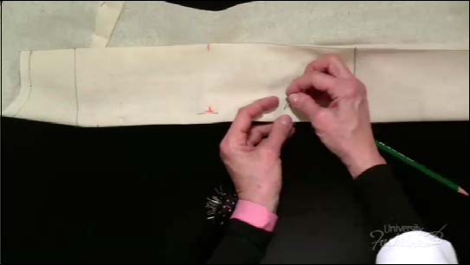

**Step 12A** Next you will true your front waist darts. Begin by placing the bust guideline dart face up on the fold. Carefully redirect the pins without lifting the point from the muslin so that they are at right angles to the dart.

166

**Module 11 – Trueing the Side Seam & Front Part 2**

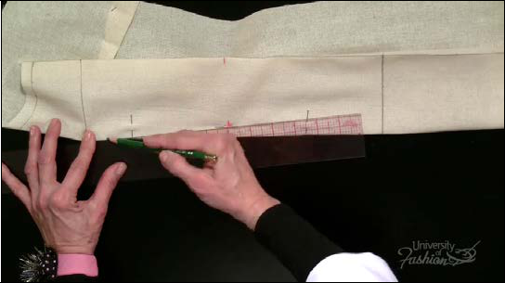

**Step 12B** Connect the vanishing point of the upper waist dart to the waist with your clear plastic ruler.

167

**Module 11 – Trueing the Side Seam & Front Part 2**

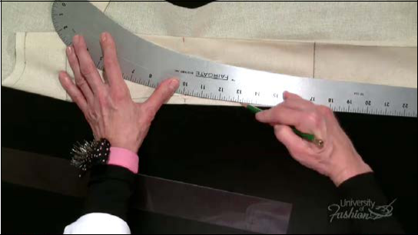

**Step 12C** With your hip curve, connect the lower waist dart from waist to vanishing point.

168

**Module 11 – Trueing the Side Seam & Front Part 2**

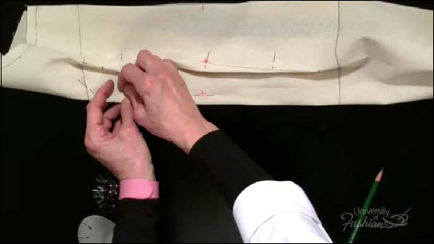

**Step 13A** With your front balance waist dart face up on the fold, redirect your pins at right angles to the dart.

169

**Module 11 – Trueing the Side Seam & Front Part 2**

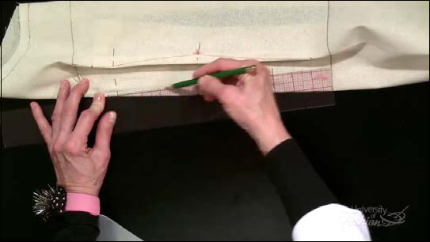

**Step 13B** Connect the upper waist dart from vanishing point to the waist.

170

**Module 11 – Trueing the Side Seam & Front Part 2**

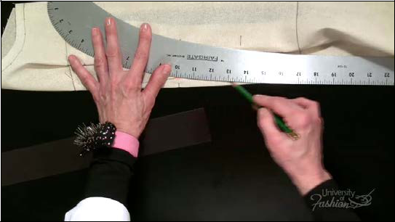

**Step 13C** With your hip curve, connect the lower waist dart from waist to vanishing point.

171

**Module 11 – Trueing the Side Seam & Front Part 2**

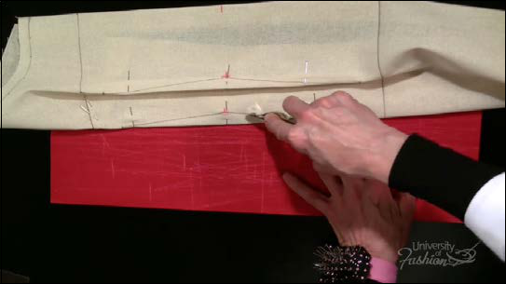

**Step 13D** Place tracing paper face-up under the balance waist dart and trace the vanishing points, the dart stitching line and the waist of the dart.

172

**Module 11 – Trueing the Side Seam & Front Part 2**

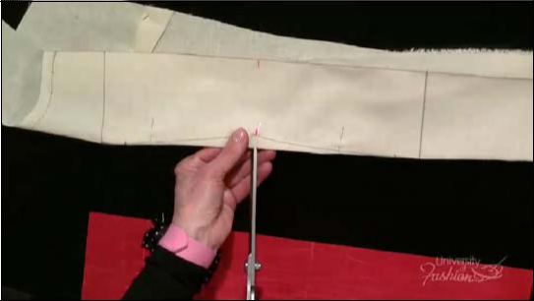

**Step 13E** Slash into both waist darts at the waist.

173

**Module 11 – Trueing the Side Seam & Front Part 2**

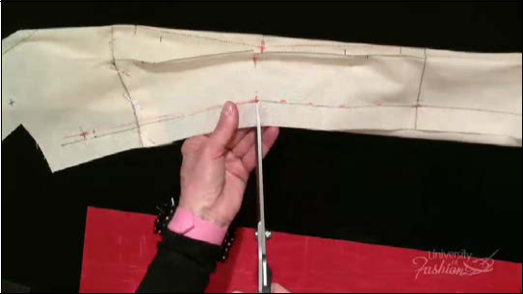

**Step 14** Slash into the waist seam allowance at the side seam. This releases the muslin for a better fit.

174

**Module 11 – Trueing the Side Seam & Front Part 2**

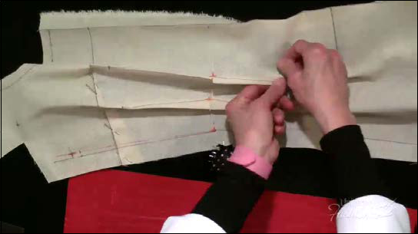

**Step 15** Remove all of the dart pins and smooth the drape so that it is flat on the table.

175

**Module 11 – Trueing the Side Seam & Front Part 2**

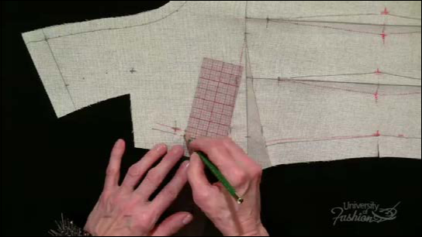

**Step 16** Square a line for about 1/4” off the lowered extended side seam.

176

**Module 11 – Trueing the Side Seam & Front Part 2**

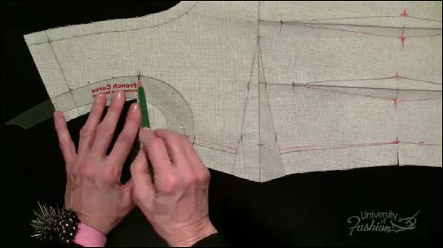

**Step 17A** Position your French curve on the armhole so that the curve rests on the shoulder, the center of the armhole plate marking and the lowered extended armhole. Draw in your armhole.

177

**Module 11 – Trueing the Side Seam & Front Part 2**

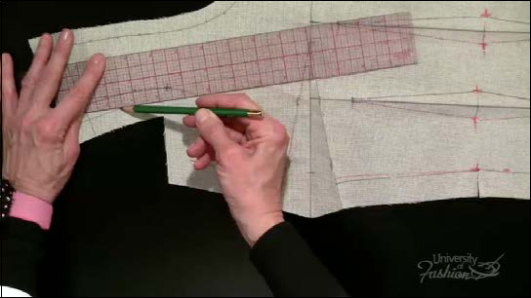

**Step 17B** Add 1/2” seam allowance to the armhole.

178

**Module 11 – Trueing the Side Seam & Front Part 2**

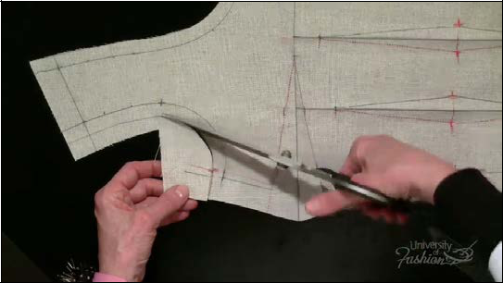

**Step 17C** Trim the excess muslin at the armhole.

179

**Module 11 – Trueing the Side Seam & Front Part 2**

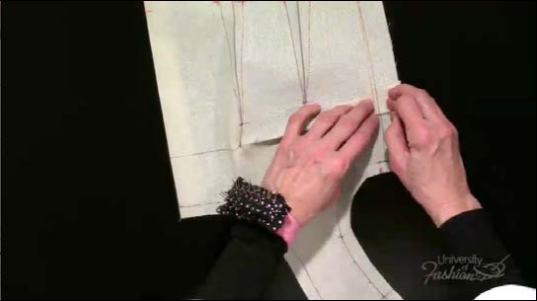

**Step 18** Pin the bust dart closed with the bottom of the dart over the top.

180

**Module 11 – Trueing the Side Seam & Front Part 2**

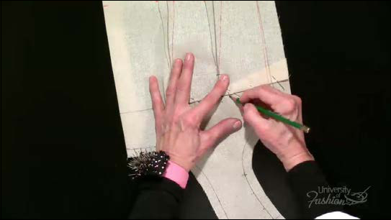

**Step 18B** Place a notch mark at the center of the bust dart.

181

**Module 11 – Trueing the Side Seam & Front Part 2**

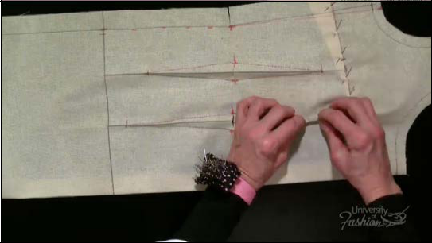

**Step 19** Fingerpress the bust guideline waist dart and pin it closed with the dart excess in the direction of center front.

182

**Module 11 – Trueing the Side Seam & Front Part 2**

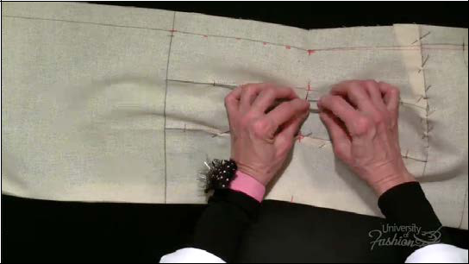

**Step 20** Fingerpress the balance guideline waist dart and pin it closed, again, with the dart excess in the direction of center front.

183

**Lesson Guide** **Sheath Dress/Scoop Neck** **Draping: Beginner**

**Module 12 – Trueing the Back**

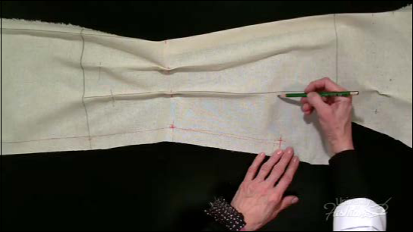

**Step 1A** At the same level as the back lowered extended armhole, mark the vanishing point of your back upper balance guideline waist dart.

184

**Module 12 – Trueing the Back**

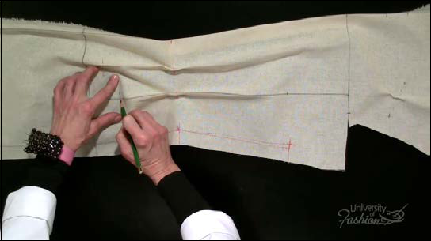

**Step 1B** Mark the vanishing point of the lower balance guideline waist dart. Remember, this dart should not vanish closer than 1” away from the hipline.

185

**Module 12 – Trueing the Back**

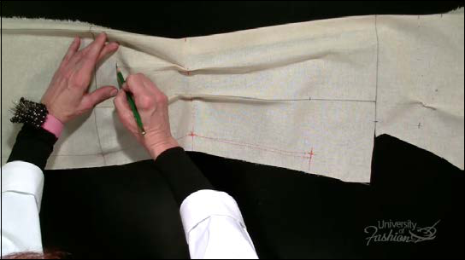

**Step 2** Mark the vanishing point of the lower midway waist dart and remove the pins.

186

**Module 12 – Trueing the Back**

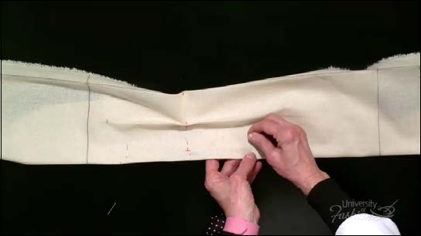

**Step 3** Place the back guideline waist dart face up on the fold. Pin the dart flat at a right an-gle to the fold.

187

**Module 12 – Trueing the Back**

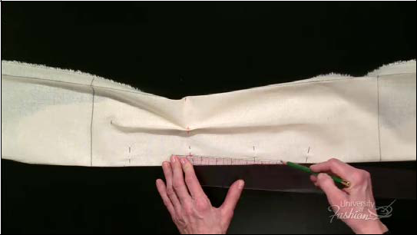

**Step 4A** True the upper leg of the guideline waist dart with your ruler from waist to vanishing point.

188

**Module 12 – Trueing the Back**

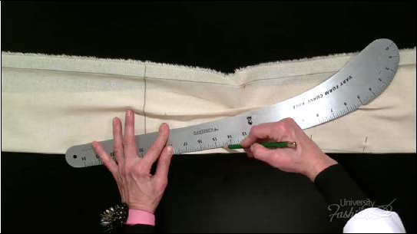

**Step 4B** Use your hip curve to true the lower leg of the back guideline dart from the vanishing point to the waist.

189

**Module 12 – Trueing the Back**

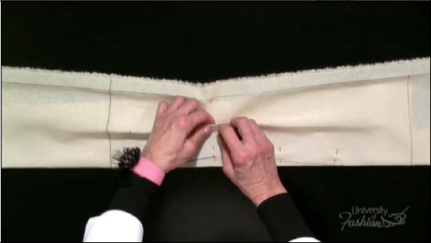

**Step 5A** Fingerpress the back midway waist dart at the waist then remove the pin.

190

**Module 12 – Trueing the Back**

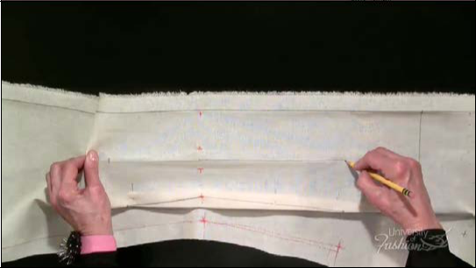

**Step 5B** At the center of the back midway dart, drag a guideline up to the same level as the back guideline dart.

191

**Module 12 – Trueing the Back**

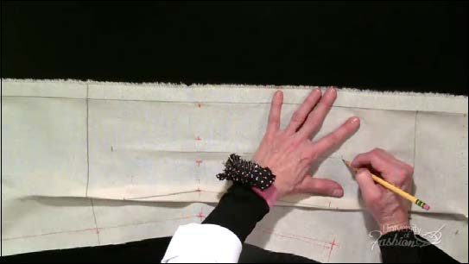

**Step 5C** Mark the vanishing point of the midway dart.

192

**Module 12 – Trueing the Back**

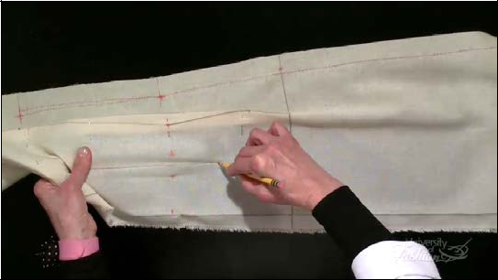

**Step 5D** Drag a grainline down the center of the midway dart to the vanishing point. Place a mark.

193

**Module 12 – Trueing the Back**

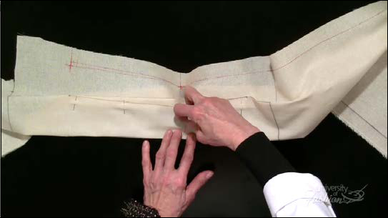

**Step 5E** Place the back midway waist dart face up on the fold. Pin the dart flat at a right an-gle to the fold.

194

**Module 12 – Trueing the Back**

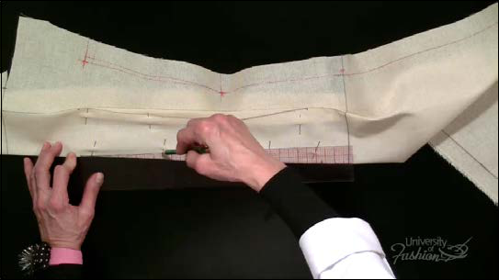

**Step 5F** True the upper leg of the midway waist dart with your ruler from the vanishing point to the waist.

195

**Module 12 – Trueing the Back**

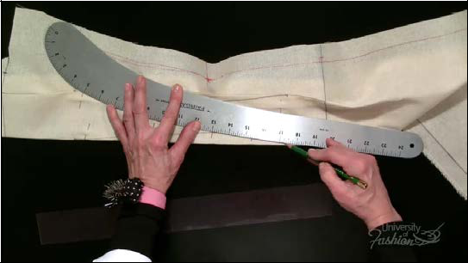

**Step 5G** Use your hip curve to true the lower leg of the back guideline dart from the waist to the vanishing point.

196

**Module 12 – Trueing the Back**

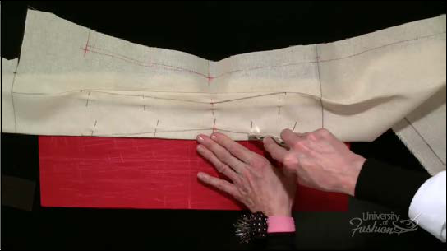

**Step 6** Place tracing paper face-up under the midway waist dart. Trace the dart’s vanishing points, stitching line and center, onto the other side.

197

**Module 12 – Trueing the Back**

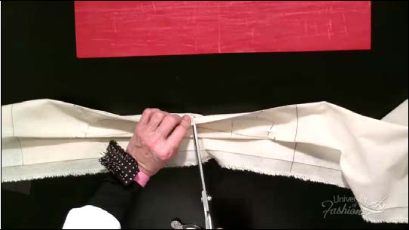

**Step 7** Slash into the seam allowance of the darts at the waist to release the muslin.

198

**Module 12 – Trueing the Back**

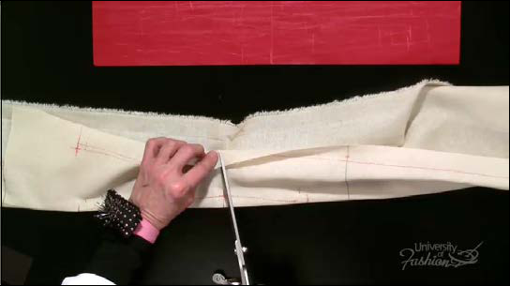

**Step 8** Slash into the seam allowance of the side seam at the waist.

199

**Module 12 – Trueing the Back**

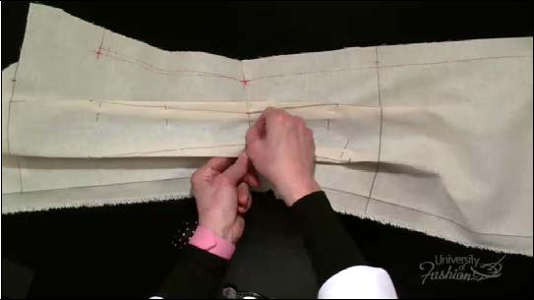

**Step 9** Remove the dart pins.

200

**Module 12 – Trueing the Back**

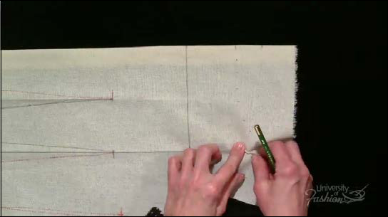

**Step 10** Remove the ease pin at the back shoulder.

201

**Module 12 – Trueing the Back**

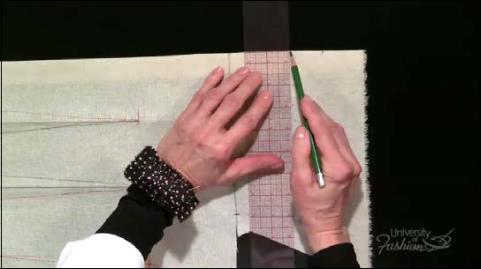

**Step 11A** Square a line off the center back neckline for 1”.

202

**Module 12 – Trueing the Back**

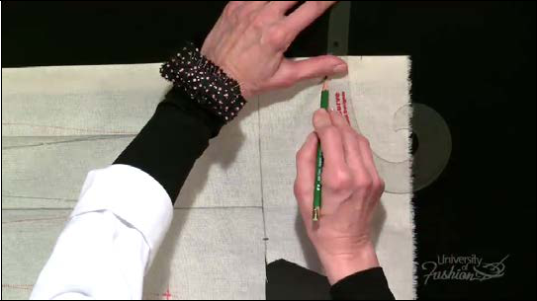

**Step 11B** Use your French curve to true the neckline curve.

203

**Module 12 – Trueing the Back**

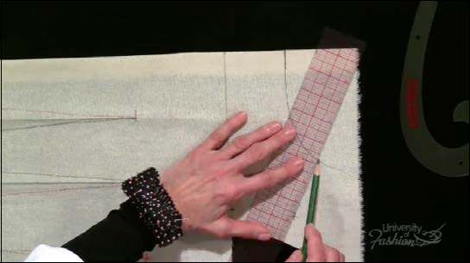

**Step 11C** True the shoulder.

204

**Module 12 – Trueing the Back**

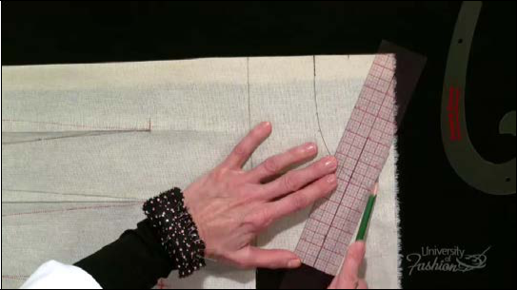

**Step 11D** Add 1” seam allowance to the shoulder seam.

205

**Module 12 – Trueing the Back**

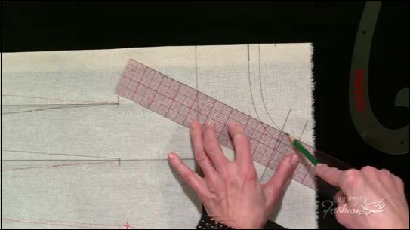

**Step 11E** Add 1/2” seam allowance to the neckline.

206

**Module 12 – Trueing the Back**

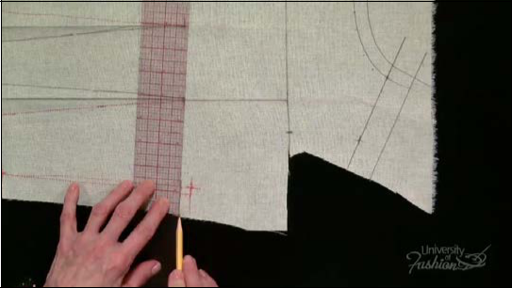

**Step 11F** Square a line off the lowered extended side seam into to body for 1/4” and extend it into the seam allowance.

207

**Module 12 – Trueing the Back**

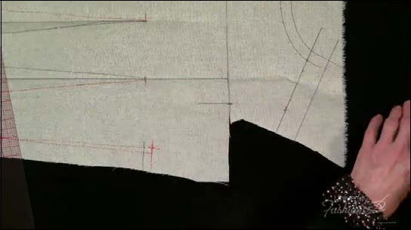

**Step 12A** In preparation for trueing the armhole, drag a grainline down from the shoulder blade/armhole mark for 2”. This guideline will help in trueing the lower armhole.

208

**Module 12 – Trueing the Back**

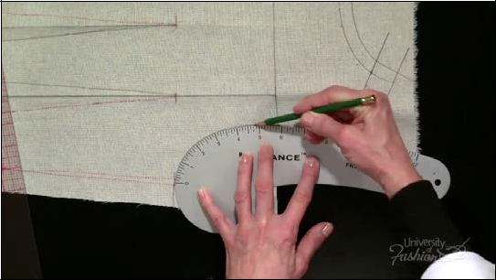

**Step 12B** Use your styling curve to true the armhole.

209

**Module 12 – Trueing the Back**

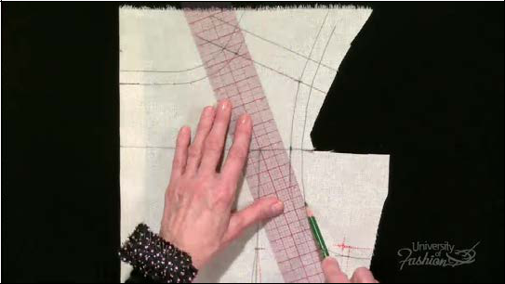

**Step 12C** Add 1/2” seam allowance to the armhole.

210

**Module 12 – Trueing the Back**

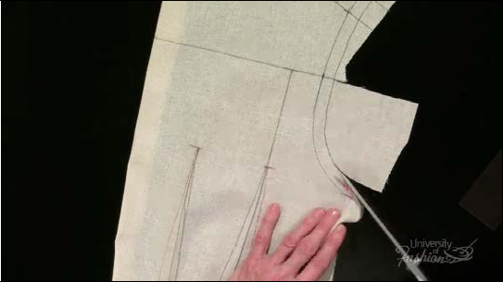

**Step 12D** Trim the excess muslin at the armhole, shoulder and neckline.

211

**Module 12 – Trueing the Back**

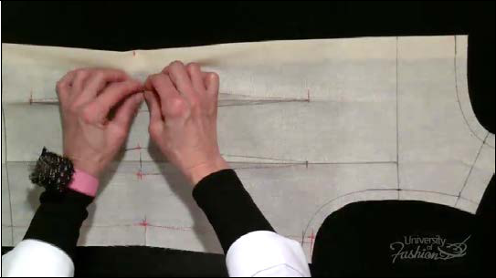

**Step 13A** Fingerpress the waist dart stitching lines closest to center back.

212

**Module 12 – Trueing the Back**

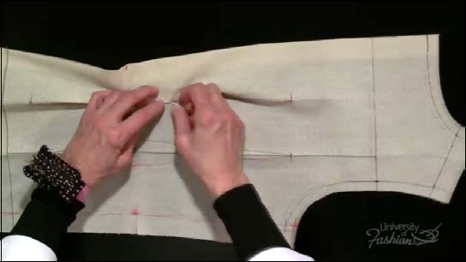

**Step 13B** Pin both waist darts closed with the dart excess in the direction of center back.

Pinning in a diagonal direction helps the drape lay flatter on the dress form.

213

**Lesson Guide** **Sheath Dress/Scoop Neck** **Draping: Beginner**

**Module 13 – Final Steps**

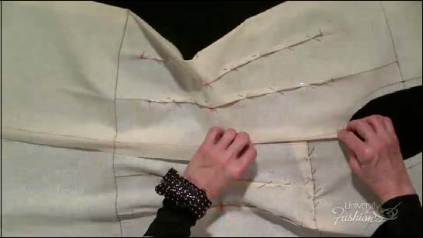

**Step 1A** Fold over the back side seam allowance and then pin the side seams together, back over front.

214

**Module 13 – Final Steps**

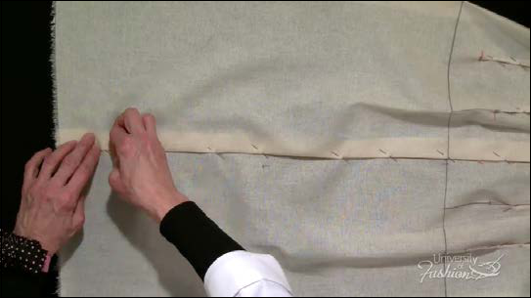

**Step 1B** Start pinning from the armhole to the hem. Match the waist and hipline as you diag-onally pin.

215

**Module 13 – Final Steps**

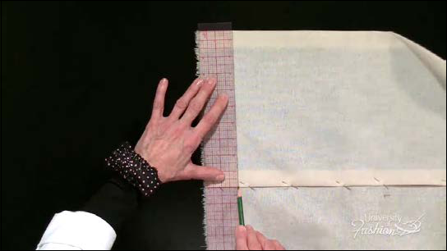

**Step 2A** Square a line off center back 2” up from the bottom edge of the muslin to form the hemline.

216

**Module 13 – Final Steps**

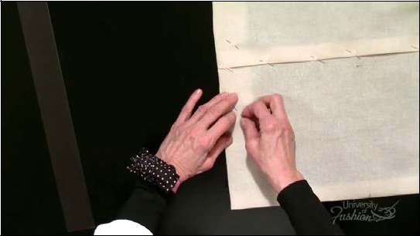

**Step 2B** Diagonally pin the hem in place from center back to center front.

217

**Module 13 – Final Steps**

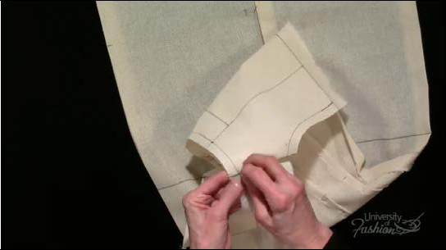

**Step 3** Pin the back shoulder over the front, trapping the ease between the pins.

218

**Module 13 – Final Steps**

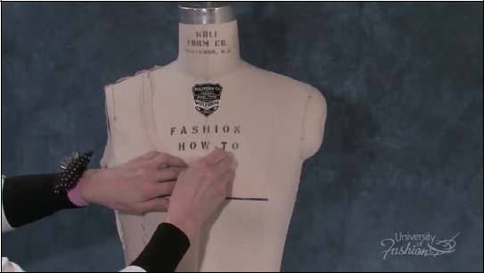

**Step 4** Pin the dress back on the dress form, the way you draped it, matching all the key points: neckline, waistline and hipline.

219

**Module 13 – Final Steps**

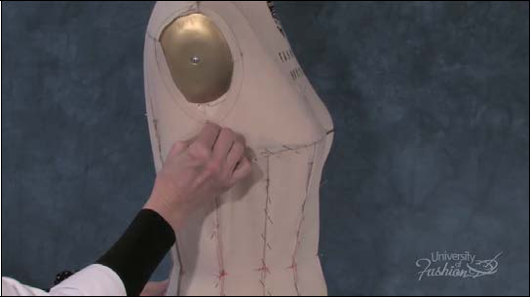

**Step 5** The last step is to check that your side seams are balanced. You should have the same amount of ease both front and back when you pinch the side seam at the armhole.

220

**Module 13 – Final Steps**

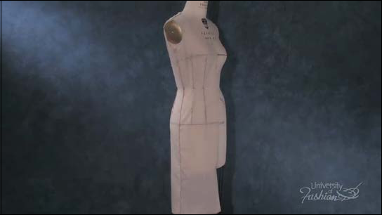

**Step 6** This is your finished sheath dress.

221